**A**

**PROJECT REPORT**

**ON**

**LIBRARY MANAGEMENT SYSTEM**

**Submitted**

**By**

Team Name:JYZ

Individual Name:

张琬涓 R8J9400040

杨思瑜 R8J9400045

姜雨含 R8J9400035

2019.5.6-2019.5.23

**Internal Guide External Guide**

**Baidu Mr.Ashok**

 

PROJECT INDEX

|  |  |  |
| --- | --- | --- |
| S no. | Particulars | Page no. |
| 1 | Team descruption & overview | 1-2 |
| 2 | About the library management system | 3-4 |
| 4 | Software,database design & diagram | 5-6 |
| 5 | Texting &Debugging | 6-7 |
| 6 | Modules | 7-9 |
| 7 | Snapshpts | 9-16 |
| 8 | Codes | 17-103 |

TEAM DESCRIPTION & OVERVIEW

**Team Logo:**

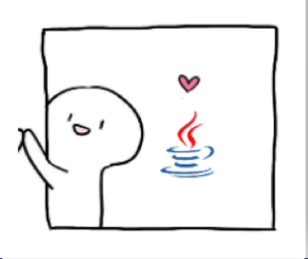

* This icon expresses our group's love for Java and our understanding of Java is not deep enough. We have just started to learn Java. It also expresses that we will continue to work hard on the way to learn Java.
* Our group is made up of Yangsiyu、Jiangyuhan and Zhangwanjuan.Our leader is Zhangwanjuan.Our team is optimistic and positive, although technically weak, but has been working hard. Our team members helped each other and completed the library management system together.

|  |  |  |  |  |
| --- | --- | --- | --- | --- |
| Work Done By | Woek task | Starting Date | Ending Date | Duration(day) |
| 张琬涓 | Analysis | 2019.5.6 | 2019.5.7 | 1 |
| 杨思瑜&姜雨含 | Design | 2019.5.7 | 2019.5.8 | 1 |
| 杨思瑜&张琬涓 | Code generation | 2019.5.8 | 2019.5.19 | 12 |
| 张琬涓&姜雨含&杨思瑜 | Report Writting | 2019.19 | 2019.5.22 | 4 |
| 姜雨含 | Intergration&  Testing | 2019.5.22 | 2019.5.23 | 1 |
|  |  |  |  | 19 |

ACKNOWLEDGEMENT

After two weeks' efforts, our group completed our project with the help and guidance of respected Mr. Liu and Mr. Ashok. In the process of completion of the project, we encountered some content beyond our scope of study, and did not find the right solution to collect information online.We asked two teachers. Both of them patiently and carefully answered our questions. With the help of the teachers, our problems were solved smoothly. And what impressed me was that after the first inspection of our project,  the two teachers told us about the problems in programming and put forward valuable suggestions.  
In this semester's study, the two teachers also do their best to answer our questions and solve our doubts, which has benefited me a lot. In this regard, we are very grateful to the two teachers.

**PROJECT REPORT**

Library Management System

The library management system should prepare and provide uniform format information for users, simplify the statistical work of librarians, reduce labor costs and information costs; provide timely and comprehensive information with different fineness and different requirements, which has reached the fastest speed to analyze and explain phenomena, while ensuring the correctness of control; use the system to comprehensively save a large amount of information and make full use of investigation.  
 The role of inquiry and synthesis can provide information support for decision makers. The main parts of library management system

**Software Requirements**

* MySQL 5.5 Command Line Client
* MySql workbench 6.0 CE
* NetBeans 7.1
* jdk-6u3-fcs-bin-b05-windows-i586-p-24_sep_2007

**SDLC of the Project**

This system is a JAVA application program, which uses Java to link database.

**Requirement Analysis**

Before starting the project, the first thing which should be considered are the requirements. A good library management system must have a friendly and convenient user interface, which can make the interface simple and convenient to operate and meet the daily business processing needs of city libraries and universities. It can not only reduce the labor intensity of managers, improve their work efficiency, but also provide convenience for readers to access information and make full use of Library resources. Rational allocation and clear division of labor among librarians can make the process of purchasing books more rational, thus enhancing the sharing and mobility of Library resources.  
 In addition, with the help of the advantages of the library management system, it can also realize the transformation of the traditional library management mode, and effectively improve the level of library management and service.

* **Entering, storing and searching of employing information manually are time consuming and error prone process:** the information may include the personal detail of an employee, past history, skills and experience. HRMS records the information’s starting with the applications summated by a candidate and will continue adding new information like selection, training, appraisals, project handle and the other activities involved. This information is to be maintained through out an employees trainer and there after also-for official records. The manual handling of all these functions will required more time and persons for the proper functioning of the HR process. The older book keeping methods generate several other problems when entering a new record of deleting and updating and existing one.
* **The second task which is very important is the time management:** this is about the working days calculation according the attendance records available. This is also about analyzing the time to work ratio for all employees. Similarly, wok load distribution is concerned whit HR management and manually it is very difficult to handle. An automatic system is always required here.
* **Calculating salary and making salary slips of large number employee is quite cumbersome:** the automation of this process becomes most important as it is a periodic process. The calculation of salary is not easy process as it takes care of all the accounting information of an employee the package being received, working days, leaves, benefits program being participate by the employee, pension plan, insurance policy, medical facility etc. handling of all this information and calculating salary periodically every one needs an automated system which can helps the HR professional to perform their task in an efficient manner.

To solve all these problems we can develop a HRMS which will help to automate all the above discussed task associated with HR department. The requirement analysis can be discussed with a much broader view but this given analysis is enough to put a basic platform to build our new system.

**Software Design**

The software is designed to solve the problems of library management of books and books. A system is made up of several parts. The first part is "query" by book deletion. The second part is reader information query, reader management and reader addition. The third part is the function of borrowing and returning books.

**Database Design**

The whole project is in fact an information management system, which interacts with the database having a number of tables. The tables with their column names and data type are as follows.

|  |  |  |  |  |
| --- | --- | --- | --- | --- |
| Table reader | | | | |
| Field Name | Data Type | Size | Primary Key | Null |
| reader_number | int | 6 | YES | NO |
| reader_name | varchar | 20 |  |  |
| reader_class | varchar | 20 |  |  |

|  |  |  |  |  |
| --- | --- | --- | --- | --- |
| Table_book | | | | |
| Field Name | Date Type | Size | Primary Key | Null |
| book_number | varchar | 6 |  | No |
| book_name | varchar | 100 |  | No |
| author | varchar | 100 |  | No |
| publishing_house | varchar | 100 |  | No |
| wether_to_borrow | varchar | 5 |  | No |

|  |  |  |  |  |
| --- | --- | --- | --- | --- |
| Table_borrowbook | | | | |
| Filed Name | Date Type | Size | Primary Key | Null |
| book_number | varchar | 6 |  | No |
| reader_number | int | 6 |  | No |
| borrow_date | date |  |  |  |
| return_date | date |  |  |  |

**Data Flow Diagram:**

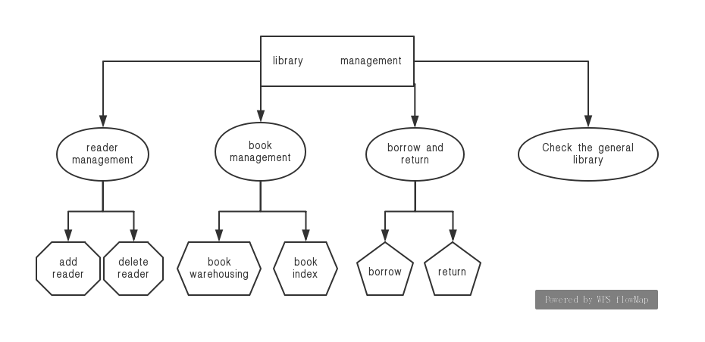

**Testing**

Before the implementation, functioning of the whole projects need to be tested for normal user login, book storage, book query and book lending. This is only after a throughout testing process, when the project is ready to be implemented and to be used by the client in the real environment. After designing and developing, the application is tested for all logical paths and proper working of all operations.

**Debugging**

Debugging is the process of isolating and correcting the causes of known errors. Commonly used debugging methods include:

* Debugging by induction or deduction
* Debugging by backtracking

Debugging by induction or deduction proceeds as follows:

* Listing the possible causes for the observed failure
* Using the available information to eliminate various hypotheses
* Elaborating the remaining hypotheses
* Proving or disproving each hypotheses
* Determining the appropriate corrections
* Verifying the corrections

**Unit Testing**

A program unit is usually small enough that the programmer who developed it can test it in great detail and certainly in greater detail than will be possible when the unit is integrated into an evolving software product. There are four categories of tests that a programmer will typically perform on a program unit:

* Functional tests—specify operating condition, input values and expected results. For example, for a function written for string copy, the source or destination string can be passed as null argument. The function should be able to take care of that situation.
* Performance tests—should be designed to verify response time, execution time, throughput, primary and secondary memory utilization and traffic rates on data channels and communication links. For example, a query executed takes 5 seconds to display results, is a test for response time. Execution time is the time taken by CPU to execute a program. Throughput is the rate at which data gets transferred from one data source to destination. Primary and secondary memory utilization needs to be optimized. Traffic rates on data channels and communication link testing is applicable for networks.
* Stress tests—are designed to overload a system in various ways. The purpose of a stress test is to determine the limitation of the system.
* Structural tests—are concerned with examining the internal processing logic of a software system.

**System Testing**

A system is tested for online responses, volume of transactions, stress, recovery from failure, and usability.System testing involves two kind of activities—Integration testing and acceptance testing.

**Integration Testing**

Bottom-up integration is the traditional strategy used to integrate the components of a software system into a functioning whole. Bottom-up integration consists of unit testing, followed by subsystem testing, followed by testing of the entire system. Unit testing has the goal of discovering errors in the individual modules of the system. The primary purpose of subsystem testing is to verify operation of the interfaces between modules in the subsystem. System testing is concerned with the decision logic, control flow, recovery procedures, and throughput, capacity and timing characteristics of the entire system.

Disadvantages of bottom-up testing include:

* Necessity to write and debug test harnesses for modules and subsystems
* Level of complexity that result from combining modules and subsystems into larger units.

Top-down integration starts with the main routine and one or two immediate subordinated routines in the system structure. Top-down integration offers several advantages:

* System integration is distributed throughout the implementation phase. Modules are integrated as they are developed
* Top-level interfaces are tested first
* The top-level routines provide a natural test harness for lower-level routines
* Errors are localized to the new modules and interfaces that are being added

Automated tools in integration testing include:

* Module drivers
* Test data generators
* Environment simulators
* Library management facility to allow easy configuration and reconfiguration of system elements

**Acceptance Testing**

Acceptance testing involves planning and execution of functional tests, performance tests and stress tests in order to demonstrate that the implemented system satisfies its requirements.

Tools of special importance during acceptance testing include:

* Test Coverage Analyzer—records the control paths followed for each test case.
* Timing Analyzer—also called a profiler, reports the time spent in various regions of the source code under different test cases. These regions of the code are areas to concentrate on to improve system performance.
* Coding Standards—static analyzer and standard checkers are used to inspect code for deviations from standards and guidelines.

**Developing the Reader Login Module**

This module is developed for readers to add personal information and delete information.The designed login module is being developed to allow only authorized person to access the available interface and links to add, update and search the important data.

The development of this module includes writing code for the following files:

* import com.mysql.jdbc.Connection;
* import com.mysql.jdbc.PreparedStatement;
* import java.sql.SQLException;
* import java.util.logging.Level;
* import java.util.logging.Logger;
* import javax.swing.JOptionPane;
* import com.mysql.jdbc.ResultSet;

**Developing** **Library Module**

This module is used for the administrator to input the new book data into the system. The administrator enters new books'book number, title, author and publisher, then puts the new books into the library.

The development of this module includes writing code for the following files:

* import com.mysql.jdbc.Connection;
* import com.mysql.jdbc.PreparedStatement;
* import com.mysql.jdbc.ResultSet;
* import com.mysql.jdbc.ResultSetMetaData;
* import java.sql.SQLException;
* import java.util.ArrayList;
* import java.util.Arrays;
* import java.util.List;
* import java.util.logging.Level;
* import java.util.logging.Logger;
* import javax.swing.table.DefaultTableModel;

**Developing Library Lending Module**

When the reader borrows the book, first looks up the concrete information of the book through the title, again in borrows the information of the book input in the interface, finally borrows successfully.

The development of this module includes writing code for the following files:

* import com.mysql.jdbc.Connection;
* import com.mysql.jdbc.PreparedStatement;
* import com.mysql.jdbc.ResultSet;
* import java.sql.SQLException;
* import java.util.Date;
* import java.util.logging.Level;
* import java.util.logging.Logger;
* import javax.swing.JOptionPane;

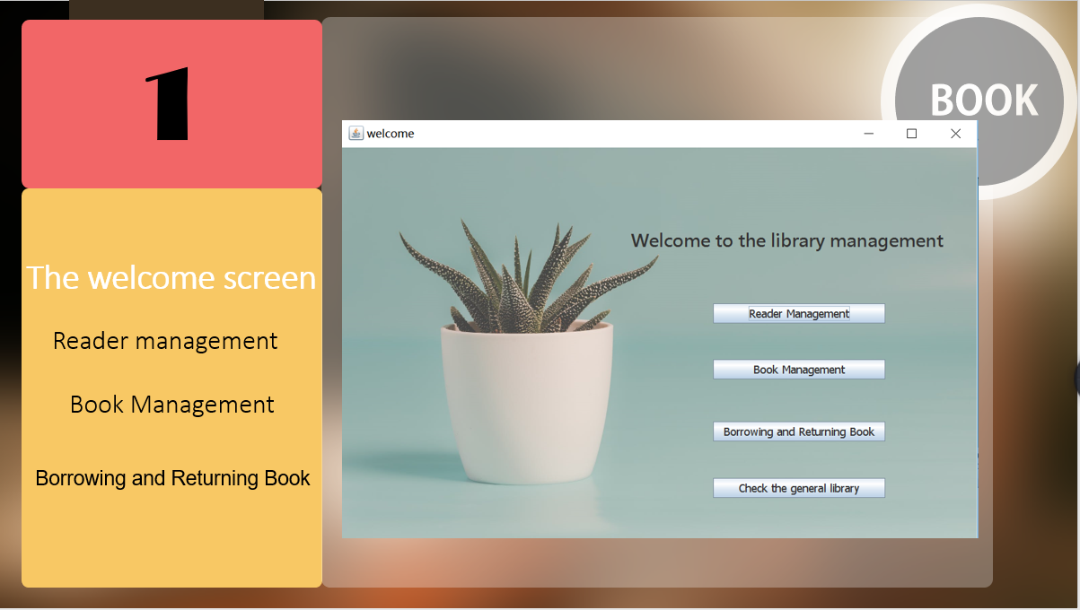

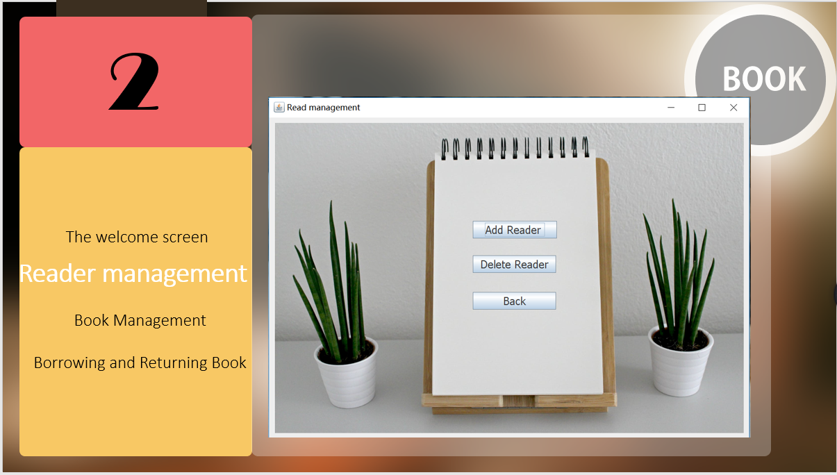

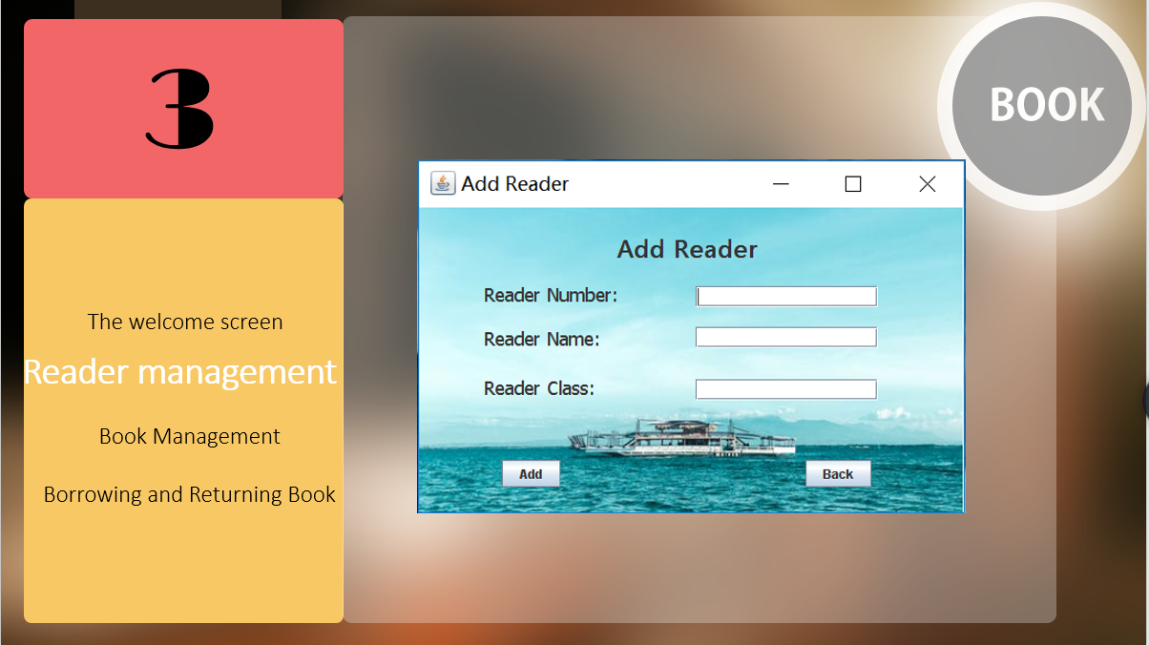

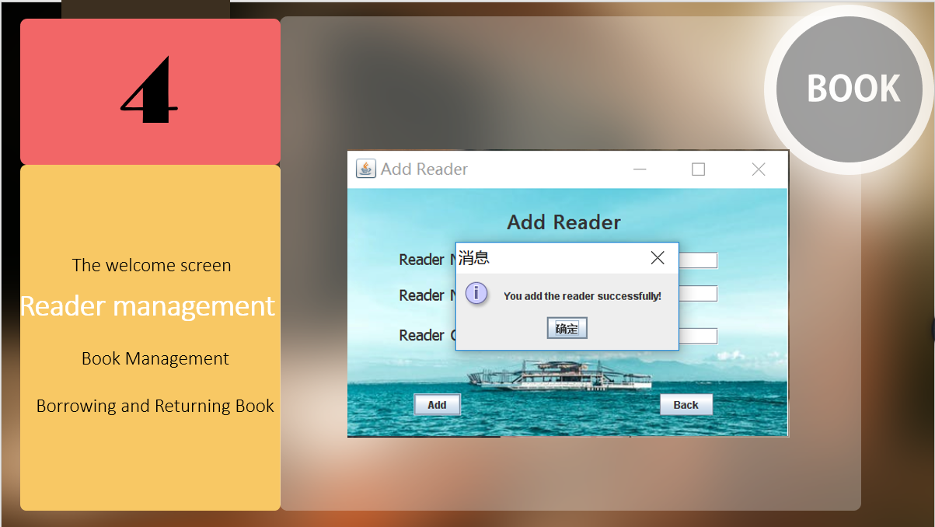

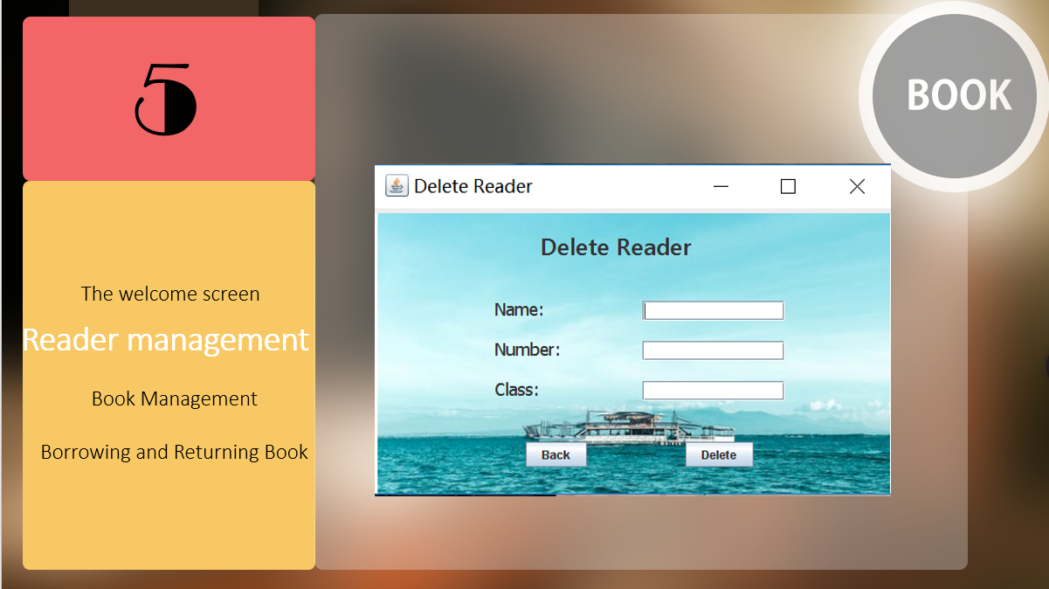

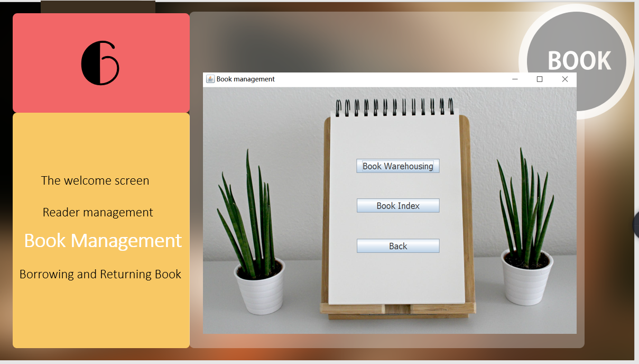

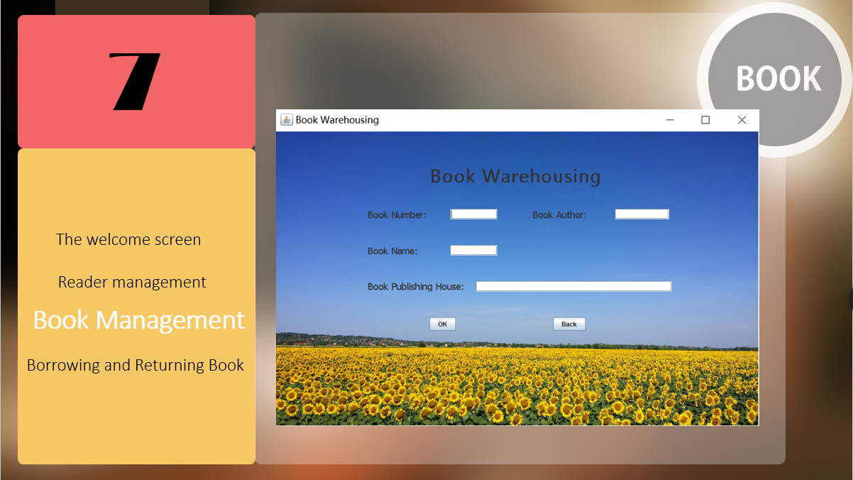

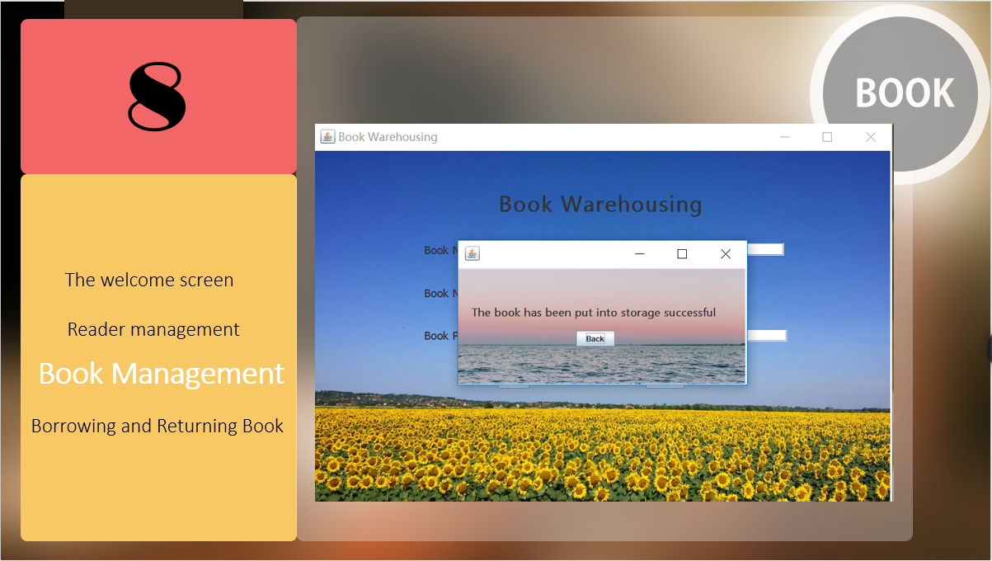

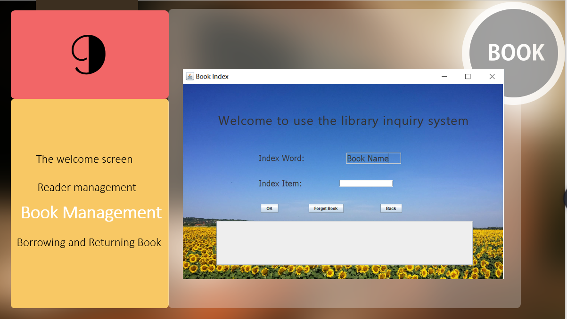

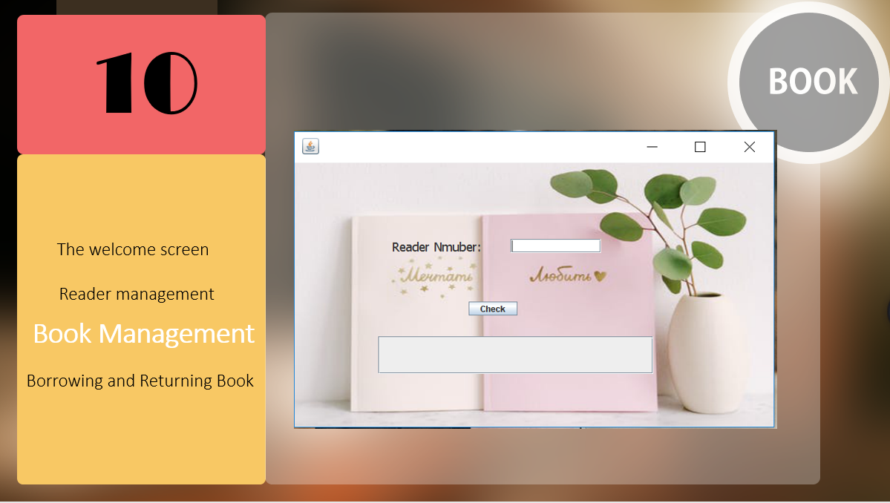

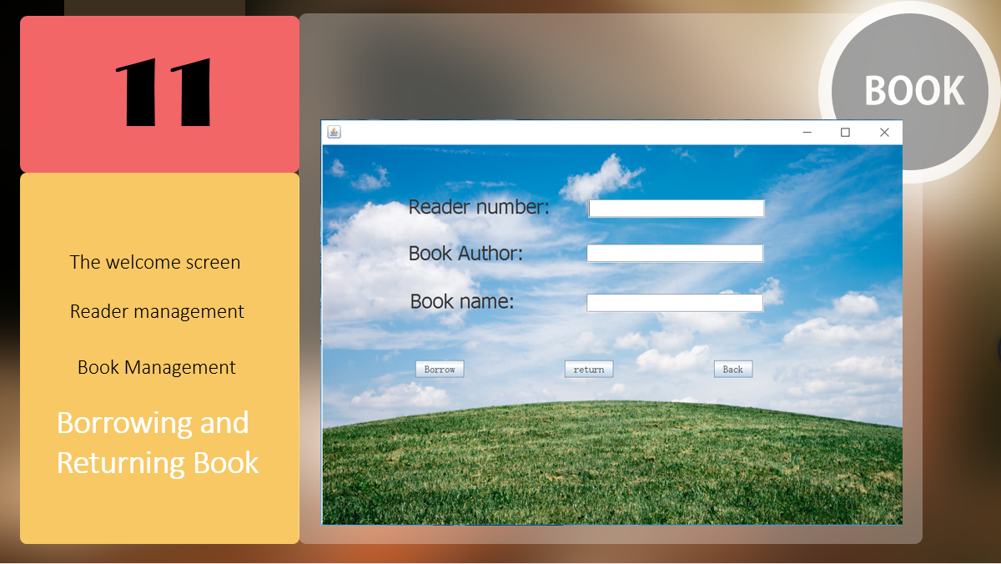

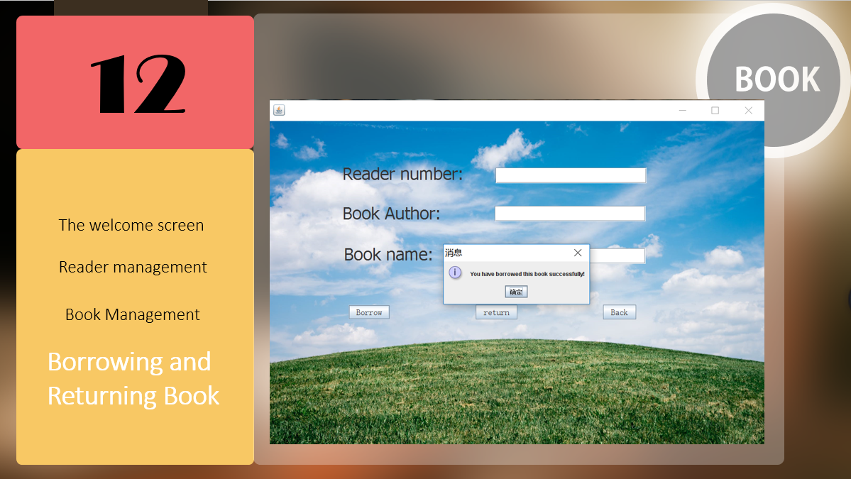

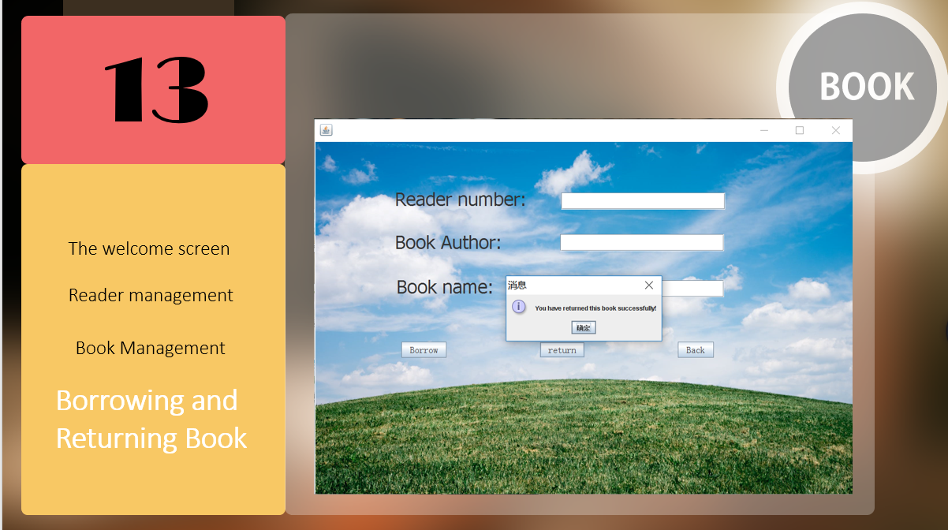

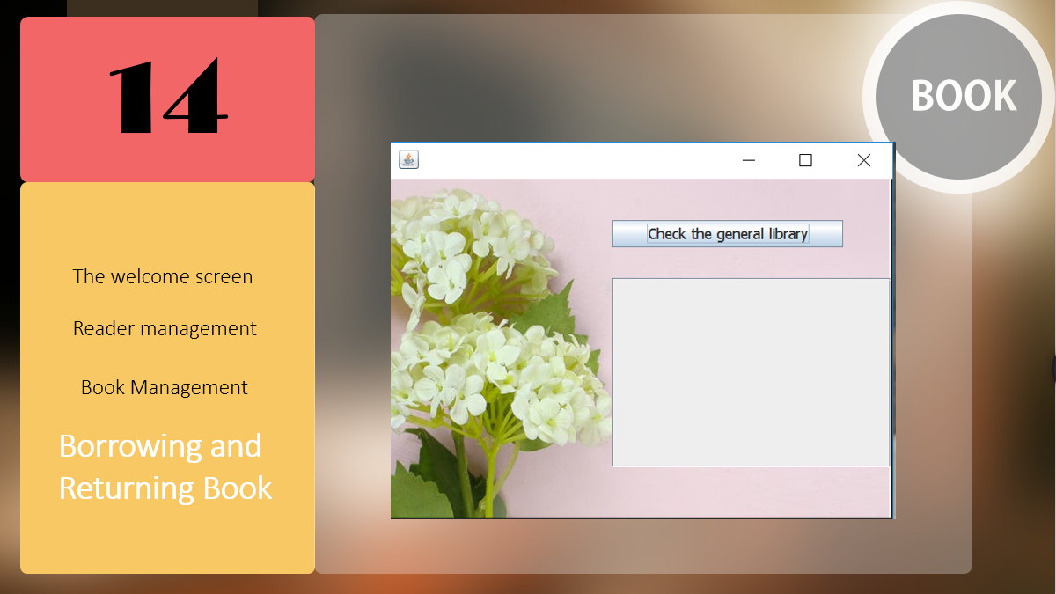

**Codes of welcome.java**

package library_management;

public class welcome extends javax.swing.JFrame {

public welcome() {

initComponents();

setLocationRelativeTo(null);

}

/**

* This method is called from within the constructor to initialize the form.

* WARNING: Do NOT modify this code. The content of this method is always

* regenerated by the Form Editor.

*/

@SuppressWarnings("unchecked")

// <editor-fold defaultstate="collapsed" desc="Generated Code">

private void initComponents() {

jPanel2 = new javax.swing.JPanel();

jPanel1 = new javax.swing.JPanel();

jButton3 = new javax.swing.JButton();

jLabel1 = new javax.swing.JLabel();

jButton1 = new javax.swing.JButton();

jButton2 = new javax.swing.JButton();

jButton4 = new javax.swing.JButton();

jLabel2 = new javax.swing.JLabel();

setTitle("welcome");

jPanel2.setLayout(new org.netbeans.lib.awtextra.AbsoluteLayout());

jPanel1.setOpaque(false);

jButton3.setFont(new java.awt.Font("Tahoma", 0, 18)); // NOI18N

jButton3.setText("Borrowing and Returning Book");

jButton3.addMouseListener(new java.awt.event.MouseAdapter() {

public void mouseClicked(java.awt.event.MouseEvent evt) {

jButton3MouseClicked(evt);

}

});

jButton3.addActionListener(new java.awt.event.ActionListener() {

public void actionPerformed(java.awt.event.ActionEvent evt) {

jButton3ActionPerformed(evt);

}

});

jLabel1.setFont(new java.awt.Font("Segoe UI Semibold", 1, 30)); // NOI18N

jLabel1.setText("Welcome to the library management");

jButton1.setFont(new java.awt.Font("Tahoma", 0, 18)); // NOI18N

jButton1.setText("Reader Management");

jButton1.addMouseListener(new java.awt.event.MouseAdapter() {

public void mouseClicked(java.awt.event.MouseEvent evt) {

jButton1MouseClicked(evt);

}

});

jButton2.setFont(new java.awt.Font("Tahoma", 0, 18)); // NOI18N

jButton2.setText("Book Management");

jButton2.addMouseListener(new java.awt.event.MouseAdapter() {

public void mouseClicked(java.awt.event.MouseEvent evt) {

jButton2MouseClicked(evt);

}

});

jButton2.addActionListener(new java.awt.event.ActionListener() {

public void actionPerformed(java.awt.event.ActionEvent evt) {

jButton2ActionPerformed(evt);

}

});

jButton4.setFont(new java.awt.Font("Tahoma", 0, 18)); // NOI18N

jButton4.setText("Check the general library");

jButton4.addMouseListener(new java.awt.event.MouseAdapter() {

public void mouseClicked(java.awt.event.MouseEvent evt) {

jButton4MouseClicked(evt);

}

});

jButton4.addActionListener(new java.awt.event.ActionListener() {

public void actionPerformed(java.awt.event.ActionEvent evt) {

jButton4ActionPerformed(evt);

}

});

javax.swing.GroupLayout jPanel1Layout = new javax.swing.GroupLayout(jPanel1);

jPanel1.setLayout(jPanel1Layout);

jPanel1Layout.setHorizontalGroup(

jPanel1Layout.createParallelGroup(javax.swing.GroupLayout.Alignment.LEADING)

.addGroup(jPanel1Layout.createSequentialGroup()

.addContainerGap(537, Short.MAX_VALUE)

.addGroup(jPanel1Layout.createParallelGroup(javax.swing.GroupLayout.Alignment.LEADING)

.addGroup(javax.swing.GroupLayout.Alignment.TRAILING, jPanel1Layout.createSequentialGroup()

.addComponent(jLabel1)

.addContainerGap())

.addGroup(javax.swing.GroupLayout.Alignment.TRAILING, jPanel1Layout.createSequentialGroup()

.addGroup(jPanel1Layout.createParallelGroup(javax.swing.GroupLayout.Alignment.LEADING, false)

.addComponent(jButton3, javax.swing.GroupLayout.DEFAULT_SIZE, javax.swing.GroupLayout.DEFAULT_SIZE, Short.MAX_VALUE)

.addComponent(jButton2, javax.swing.GroupLayout.DEFAULT_SIZE, javax.swing.GroupLayout.DEFAULT_SIZE, Short.MAX_VALUE)

.addComponent(jButton1, javax.swing.GroupLayout.DEFAULT_SIZE, javax.swing.GroupLayout.DEFAULT_SIZE, Short.MAX_VALUE)

.addComponent(jButton4, javax.swing.GroupLayout.DEFAULT_SIZE, javax.swing.GroupLayout.DEFAULT_SIZE, Short.MAX_VALUE))

.addGap(106, 106, 106))))

);

jPanel1Layout.setVerticalGroup(

jPanel1Layout.createParallelGroup(javax.swing.GroupLayout.Alignment.LEADING)

.addGroup(jPanel1Layout.createSequentialGroup()

.addGap(127, 127, 127)

.addComponent(jLabel1)

.addGap(83, 83, 83)

.addComponent(jButton1)

.addGap(58, 58, 58)

.addComponent(jButton2)

.addGap(68, 68, 68)

.addComponent(jButton3)

.addGap(59, 59, 59)

.addComponent(jButton4)

.addContainerGap(70, Short.MAX_VALUE))

);

jPanel2.add(jPanel1, new org.netbeans.lib.awtextra.AbsoluteConstraints(-70, 0, 1050, 630));

jLabel2.setIcon(new javax.swing.ImageIcon(getClass().getResource("/PHOTO/微信图片_20190509100936.png"))); // NOI18N

jPanel2.add(jLabel2, new org.netbeans.lib.awtextra.AbsoluteConstraints(0, -60, -1, 690));

javax.swing.GroupLayout layout = new javax.swing.GroupLayout(getContentPane());

getContentPane().setLayout(layout);

layout.setHorizontalGroup(

layout.createParallelGroup(javax.swing.GroupLayout.Alignment.LEADING)

.addComponent(jPanel2, javax.swing.GroupLayout.DEFAULT_SIZE, javax.swing.GroupLayout.DEFAULT_SIZE, Short.MAX_VALUE)

);

layout.setVerticalGroup(

layout.createParallelGroup(javax.swing.GroupLayout.Alignment.LEADING)

.addComponent(jPanel2, javax.swing.GroupLayout.Alignment.TRAILING, javax.swing.GroupLayout.DEFAULT_SIZE, javax.swing.GroupLayout.DEFAULT_SIZE, Short.MAX_VALUE)

);

pack();

}// </editor-fold>

private void jButton2ActionPerformed(java.awt.event.ActionEvent evt) {

// TODO add your handling code here:

}

private void jButton1MouseClicked(java.awt.event.MouseEvent evt) {

this.dispose();

Reader_management reader_management = new Reader_management();

reader_management.setVisible(true);// TODO add your handling code here:

}

private void jButton2MouseClicked(java.awt.event.MouseEvent evt) {

this.dispose();

Book_management book_management = new Book_management();

book_management.setVisible(true); // TODO add your handling code here:

}

private void jButton3MouseClicked(java.awt.event.MouseEvent evt) {

this.dispose();

borrow_return borrow_return = new borrow_return(); // TODO add your handling code here:

borrow_return.setVisible(true);

}

private void jButton3ActionPerformed(java.awt.event.ActionEvent evt) {

// TODO add your handling code here:

}

private void jButton4MouseClicked(java.awt.event.MouseEvent evt) {

// TODO add your handling code here:

this.dispose();

new General_library().setVisible(true);

}

private void jButton4ActionPerformed(java.awt.event.ActionEvent evt) {

// TODO add your handling code here:

}

/**

* @param args the command line arguments

*/

public static void main(String args[]) {

/*

* Set the Nimbus look and feel

*/

//<editor-fold defaultstate="collapsed" desc=" Look and feel setting code (optional) ">

/*

* If Nimbus (introduced in Java SE 6) is not available, stay with the

* default look and feel. For details see

* http://download.oracle.com/javase/tutorial/uiswing/lookandfeel/plaf.html

*/

try {

for (javax.swing.UIManager.LookAndFeelInfo info : javax.swing.UIManager.getInstalledLookAndFeels()) {

if ("Nimbus".equals(info.getName())) {

javax.swing.UIManager.setLookAndFeel(info.getClassName());

break;

}

}

} catch (ClassNotFoundException ex) {

java.util.logging.Logger.getLogger(welcome.class.getName()).log(java.util.logging.Level.SEVERE, null, ex);

} catch (InstantiationException ex) {

java.util.logging.Logger.getLogger(welcome.class.getName()).log(java.util.logging.Level.SEVERE, null, ex);

} catch (IllegalAccessException ex) {

java.util.logging.Logger.getLogger(welcome.class.getName()).log(java.util.logging.Level.SEVERE, null, ex);

} catch (javax.swing.UnsupportedLookAndFeelException ex) {

java.util.logging.Logger.getLogger(welcome.class.getName()).log(java.util.logging.Level.SEVERE, null, ex);

}

//</editor-fold>

/*

* Create and display the form

*/

java.awt.EventQueue.invokeLater(new Runnable() {

public void run() {

new welcome().setVisible(true);

}

});

}

// Variables declaration - do not modify

private javax.swing.JButton jButton1;

private javax.swing.JButton jButton2;

private javax.swing.JButton jButton3;

private javax.swing.JButton jButton4;

private javax.swing.JLabel jLabel1;

private javax.swing.JLabel jLabel2;

private javax.swing.JPanel jPanel1;

private javax.swing.JPanel jPanel2;

// End of variables declaration

}

**Codes of reader_management.java**

package library_management;

public class Reader_management extends javax.swing.JFrame {

public Reader_management() {

initComponents();

setLocationRelativeTo(null);

}

/**

* This method is called from within the constructor to initialize the form.

* WARNING: Do NOT modify this code. The content of this method is always

* regenerated by the Form Editor.

*/

@SuppressWarnings("unchecked")

// <editor-fold defaultstate="collapsed" desc="Generated Code">

private void initComponents() {

jFrame1 = new javax.swing.JFrame();

jPanel1 = new javax.swing.JPanel();

jPanel2 = new javax.swing.JPanel();

jButton3 = new javax.swing.JButton();

jButton1 = new javax.swing.JButton();

jButton2 = new javax.swing.JButton();

jLabel1 = new javax.swing.JLabel();

javax.swing.GroupLayout jFrame1Layout = new javax.swing.GroupLayout(jFrame1.getContentPane());

jFrame1.getContentPane().setLayout(jFrame1Layout);

jFrame1Layout.setHorizontalGroup(

jFrame1Layout.createParallelGroup(javax.swing.GroupLayout.Alignment.LEADING)

.addGap(0, 400, Short.MAX_VALUE)

);

jFrame1Layout.setVerticalGroup(

jFrame1Layout.createParallelGroup(javax.swing.GroupLayout.Alignment.LEADING)

.addGap(0, 300, Short.MAX_VALUE)

);

setTitle("Read management");

jPanel1.setLayout(new org.netbeans.lib.awtextra.AbsoluteLayout());

jPanel2.setOpaque(false);

jButton3.setFont(new java.awt.Font("Tahoma", 0, 24)); // NOI18N

jButton3.setText("Back");

jButton3.addMouseListener(new java.awt.event.MouseAdapter() {

public void mouseClicked(java.awt.event.MouseEvent evt) {

jButton3MouseClicked(evt);

}

});

jButton1.setFont(new java.awt.Font("Tahoma", 0, 24)); // NOI18N

jButton1.setText("Add Reader ");

jButton1.addMouseListener(new java.awt.event.MouseAdapter() {

public void mouseClicked(java.awt.event.MouseEvent evt) {

jButton1MouseClicked(evt);

}

});

jButton2.setFont(new java.awt.Font("Tahoma", 0, 24)); // NOI18N

jButton2.setText("Delete Reader");

jButton2.addMouseListener(new java.awt.event.MouseAdapter() {

public void mouseClicked(java.awt.event.MouseEvent evt) {

jButton2MouseClicked(evt);

}

});

javax.swing.GroupLayout jPanel2Layout = new javax.swing.GroupLayout(jPanel2);

jPanel2.setLayout(jPanel2Layout);

jPanel2Layout.setHorizontalGroup(

jPanel2Layout.createParallelGroup(javax.swing.GroupLayout.Alignment.LEADING)

.addGroup(jPanel2Layout.createSequentialGroup()

.addGap(104, 104, 104)

.addGroup(jPanel2Layout.createParallelGroup(javax.swing.GroupLayout.Alignment.LEADING)

.addComponent(jButton1, javax.swing.GroupLayout.PREFERRED_SIZE, 188, javax.swing.GroupLayout.PREFERRED_SIZE)

.addGroup(jPanel2Layout.createParallelGroup(javax.swing.GroupLayout.Alignment.TRAILING, false)

.addComponent(jButton3, javax.swing.GroupLayout.Alignment.LEADING, javax.swing.GroupLayout.DEFAULT_SIZE, javax.swing.GroupLayout.DEFAULT_SIZE, Short.MAX_VALUE)

.addComponent(jButton2, javax.swing.GroupLayout.Alignment.LEADING, javax.swing.GroupLayout.DEFAULT_SIZE, javax.swing.GroupLayout.DEFAULT_SIZE, Short.MAX_VALUE)))

.addContainerGap(128, Short.MAX_VALUE))

);

jPanel2Layout.setVerticalGroup(

jPanel2Layout.createParallelGroup(javax.swing.GroupLayout.Alignment.LEADING)

.addGroup(javax.swing.GroupLayout.Alignment.TRAILING, jPanel2Layout.createSequentialGroup()

.addContainerGap(95, Short.MAX_VALUE)

.addComponent(jButton1)

.addGap(38, 38, 38)

.addComponent(jButton2)

.addGap(43, 43, 43)

.addComponent(jButton3)

.addGap(83, 83, 83))

);

jPanel1.add(jPanel2, new org.netbeans.lib.awtextra.AbsoluteConstraints(340, 130, 420, 370));

jLabel1.setIcon(new javax.swing.ImageIcon(getClass().getResource("/PHOTO/微信图片_20190509100929.png"))); // NOI18N

jPanel1.add(jLabel1, new org.netbeans.lib.awtextra.AbsoluteConstraints(0, 0, -1, -1));

javax.swing.GroupLayout layout = new javax.swing.GroupLayout(getContentPane());

getContentPane().setLayout(layout);

layout.setHorizontalGroup(

layout.createParallelGroup(javax.swing.GroupLayout.Alignment.LEADING)

.addGroup(layout.createSequentialGroup()

.addContainerGap()

.addComponent(jPanel1, javax.swing.GroupLayout.DEFAULT_SIZE, javax.swing.GroupLayout.DEFAULT_SIZE, Short.MAX_VALUE)

.addContainerGap())

);

layout.setVerticalGroup(

layout.createParallelGroup(javax.swing.GroupLayout.Alignment.LEADING)

.addGroup(layout.createSequentialGroup()

.addContainerGap()

.addComponent(jPanel1, javax.swing.GroupLayout.DEFAULT_SIZE, javax.swing.GroupLayout.DEFAULT_SIZE, Short.MAX_VALUE)

.addContainerGap())

);

pack();

}// </editor-fold>

private void jButton1MouseClicked(java.awt.event.MouseEvent evt) {

this.dispose();

Add_Reader add_Reader = new Add_Reader();

add_Reader.setVisible(true); // TODO add your handling code here:

}

private void jButton2MouseClicked(java.awt.event.MouseEvent evt) {

this.dispose();

Delete_Reader delete_Reader = new Delete_Reader();

delete_Reader.setVisible(true); // TODO add your handling code here:

}

private void jButton3MouseClicked(java.awt.event.MouseEvent evt) {

this.dispose();

welcome welcome = new welcome();

welcome.setVisible(true);// TODO add your handling code here:

}

/**

* @param args the command line arguments

*/

public static void main(String args[]) {

/*

* Set the Nimbus look and feel

*/

//<editor-fold defaultstate="collapsed" desc=" Look and feel setting code (optional) ">

/*

* If Nimbus (introduced in Java SE 6) is not available, stay with the

* default look and feel. For details see

* http://download.oracle.com/javase/tutorial/uiswing/lookandfeel/plaf.html

*/

try {

for (javax.swing.UIManager.LookAndFeelInfo info : javax.swing.UIManager.getInstalledLookAndFeels()) {

if ("Nimbus".equals(info.getName())) {

javax.swing.UIManager.setLookAndFeel(info.getClassName());

break;

}

}

} catch (ClassNotFoundException ex) {

java.util.logging.Logger.getLogger(Reader_management.class.getName()).log(java.util.logging.Level.SEVERE, null, ex);

} catch (InstantiationException ex) {

java.util.logging.Logger.getLogger(Reader_management.class.getName()).log(java.util.logging.Level.SEVERE, null, ex);

} catch (IllegalAccessException ex) {

java.util.logging.Logger.getLogger(Reader_management.class.getName()).log(java.util.logging.Level.SEVERE, null, ex);

} catch (javax.swing.UnsupportedLookAndFeelException ex) {

java.util.logging.Logger.getLogger(Reader_management.class.getName()).log(java.util.logging.Level.SEVERE, null, ex);

}

//</editor-fold>

/*

* Create and display the form

*/

java.awt.EventQueue.invokeLater(new Runnable() {

public void run() {

new Reader_management().setVisible(true);

}

});

}

// Variables declaration - do not modify

private javax.swing.JButton jButton1;

private javax.swing.JButton jButton2;

private javax.swing.JButton jButton3;

private javax.swing.JFrame jFrame1;

private javax.swing.JLabel jLabel1;

private javax.swing.JPanel jPanel1;

private javax.swing.JPanel jPanel2;

// End of variables declaration

}

Codes of book_management.java

package library_management;

public class Book_management extends javax.swing.JFrame {

public Book_management() {

initComponents();

setLocationRelativeTo(null);

}

/**

* This method is called from within the constructor to initialize the form.

* WARNING: Do NOT modify this code. The content of this method is always

* regenerated by the Form Editor.

*/

@SuppressWarnings("unchecked")

// <editor-fold defaultstate="collapsed" desc="Generated Code">

private void initComponents() {

jPanel1 = new javax.swing.JPanel();

jPanel2 = new javax.swing.JPanel();

jButton2 = new javax.swing.JButton();

jButton3 = new javax.swing.JButton();

jButton1 = new javax.swing.JButton();

jLabel1 = new javax.swing.JLabel();

setTitle("Book management");

jPanel1.setLayout(new org.netbeans.lib.awtextra.AbsoluteLayout());

jPanel2.setOpaque(false);

jButton2.setFont(new java.awt.Font("Tahoma", 0, 24)); // NOI18N

jButton2.setText("Book Warehousing");

jButton2.addMouseListener(new java.awt.event.MouseAdapter() {

public void mouseClicked(java.awt.event.MouseEvent evt) {

jButton2MouseClicked(evt);

}

});

jButton3.setFont(new java.awt.Font("Tahoma", 0, 24)); // NOI18N

jButton3.setText("Back");

jButton3.addMouseListener(new java.awt.event.MouseAdapter() {

public void mouseClicked(java.awt.event.MouseEvent evt) {

jButton3MouseClicked(evt);

}

});

jButton1.setFont(new java.awt.Font("Tahoma", 0, 24)); // NOI18N

jButton1.setText("Book Index");

jButton1.addMouseListener(new java.awt.event.MouseAdapter() {

public void mouseClicked(java.awt.event.MouseEvent evt) {

jButton1MouseClicked(evt);

}

});

javax.swing.GroupLayout jPanel2Layout = new javax.swing.GroupLayout(jPanel2);

jPanel2.setLayout(jPanel2Layout);

jPanel2Layout.setHorizontalGroup(

jPanel2Layout.createParallelGroup(javax.swing.GroupLayout.Alignment.LEADING)

.addGroup(jPanel2Layout.createSequentialGroup()

.addContainerGap(javax.swing.GroupLayout.DEFAULT_SIZE, Short.MAX_VALUE)

.addGroup(jPanel2Layout.createParallelGroup(javax.swing.GroupLayout.Alignment.LEADING)

.addComponent(jButton2, javax.swing.GroupLayout.Alignment.TRAILING)

.addComponent(jButton3, javax.swing.GroupLayout.Alignment.TRAILING, javax.swing.GroupLayout.PREFERRED_SIZE, 231, javax.swing.GroupLayout.PREFERRED_SIZE)

.addComponent(jButton1, javax.swing.GroupLayout.Alignment.TRAILING, javax.swing.GroupLayout.PREFERRED_SIZE, 231, javax.swing.GroupLayout.PREFERRED_SIZE))

.addContainerGap())

);

jPanel2Layout.setVerticalGroup(

jPanel2Layout.createParallelGroup(javax.swing.GroupLayout.Alignment.LEADING)

.addGroup(jPanel2Layout.createSequentialGroup()

.addContainerGap(97, Short.MAX_VALUE)

.addComponent(jButton2)

.addGap(72, 72, 72)

.addComponent(jButton1)

.addGap(74, 74, 74)

.addComponent(jButton3)

.addGap(36, 36, 36))

);

jPanel1.add(jPanel2, new org.netbeans.lib.awtextra.AbsoluteConstraints(420, 110, -1, 390));

jLabel1.setIcon(new javax.swing.ImageIcon(getClass().getResource("/PHOTO/微信图片_20190509100929.png"))); // NOI18N

jPanel1.add(jLabel1, new org.netbeans.lib.awtextra.AbsoluteConstraints(0, 0, -1, -1));

javax.swing.GroupLayout layout = new javax.swing.GroupLayout(getContentPane());

getContentPane().setLayout(layout);

layout.setHorizontalGroup(

layout.createParallelGroup(javax.swing.GroupLayout.Alignment.LEADING)

.addComponent(jPanel1, javax.swing.GroupLayout.PREFERRED_SIZE, javax.swing.GroupLayout.DEFAULT_SIZE, javax.swing.GroupLayout.PREFERRED_SIZE)

);

layout.setVerticalGroup(

layout.createParallelGroup(javax.swing.GroupLayout.Alignment.LEADING)

.addComponent(jPanel1, javax.swing.GroupLayout.DEFAULT_SIZE, javax.swing.GroupLayout.DEFAULT_SIZE, Short.MAX_VALUE)

);

pack();

}// </editor-fold>

private void jButton1MouseClicked(java.awt.event.MouseEvent evt) {

this.dispose();

Book_Index book_Index = new Book_Index();

book_Index.setVisible(true);// TODO add your handling code here:

}

private void jButton2MouseClicked(java.awt.event.MouseEvent evt) {

this.dispose();

Book_Warehousing book_Warehousing = new Book_Warehousing();

book_Warehousing.setVisible(true);// TODO add your handling code here:

}

private void jButton3MouseClicked(java.awt.event.MouseEvent evt) {

this.dispose();

welcome welcome = new welcome();

welcome.setVisible(true);// TODO add your handling code here:

}

/**

* @param args the command line arguments

*/

public static void main(String args[]) {

/*

* Set the Nimbus look and feel

*/

//<editor-fold defaultstate="collapsed" desc=" Look and feel setting code (optional) ">

/*

* If Nimbus (introduced in Java SE 6) is not available, stay with the

* default look and feel. For details see

* http://download.oracle.com/javase/tutorial/uiswing/lookandfeel/plaf.html

*/

try {

for (javax.swing.UIManager.LookAndFeelInfo info : javax.swing.UIManager.getInstalledLookAndFeels()) {

if ("Nimbus".equals(info.getName())) {

javax.swing.UIManager.setLookAndFeel(info.getClassName());

break;

}

}

} catch (ClassNotFoundException ex) {

java.util.logging.Logger.getLogger(Book_management.class.getName()).log(java.util.logging.Level.SEVERE, null, ex);

} catch (InstantiationException ex) {

java.util.logging.Logger.getLogger(Book_management.class.getName()).log(java.util.logging.Level.SEVERE, null, ex);

} catch (IllegalAccessException ex) {

java.util.logging.Logger.getLogger(Book_management.class.getName()).log(java.util.logging.Level.SEVERE, null, ex);

} catch (javax.swing.UnsupportedLookAndFeelException ex) {

java.util.logging.Logger.getLogger(Book_management.class.getName()).log(java.util.logging.Level.SEVERE, null, ex);

}

//</editor-fold>

/*

* Create and display the form

*/

java.awt.EventQueue.invokeLater(new Runnable() {

public void run() {

new Book_management().setVisible(true);

}

});

}

// Variables declaration - do not modify

private javax.swing.JButton jButton1;

private javax.swing.JButton jButton2;

private javax.swing.JButton jButton3;

private javax.swing.JLabel jLabel1;

private javax.swing.JPanel jPanel1;

private javax.swing.JPanel jPanel2;

// End of variables declaration

}

**Codes of add_reader.java**

package library_management;

import com.mysql.jdbc.Connection;

import com.mysql.jdbc.PreparedStatement;

import java.sql.SQLException;

import java.util.logging.Level;

import java.util.logging.Logger;

import javax.swing.JOptionPane;

import com.mysql.jdbc.ResultSet;

public class Add_Reader extends javax.swing.JFrame {

boolean rs;

public Add_Reader() {

initComponents();

setLocationRelativeTo(null);

}

/**

* This method is called from within the constructor to initialize the form.

* WARNING: Do NOT modify this code. The content of this method is always

* regenerated by the Form Editor.

*/

@SuppressWarnings("unchecked")

// <editor-fold defaultstate="collapsed" desc="Generated Code">

private void initComponents() {

jPanel1 = new javax.swing.JPanel();

jPanel2 = new javax.swing.JPanel();

jLabel1 = new javax.swing.JLabel();

jLabel2 = new javax.swing.JLabel();

jLabel3 = new javax.swing.JLabel();

jLabel4 = new javax.swing.JLabel();

jButton1 = new javax.swing.JButton();

jButton2 = new javax.swing.JButton();

JT2 = new javax.swing.JTextField();

JT3 = new javax.swing.JTextField();

JT1 = new javax.swing.JTextField();

jLabel5 = new javax.swing.JLabel();

setDefaultCloseOperation(javax.swing.WindowConstants.DISPOSE_ON_CLOSE);

setTitle("Add Reader");

jPanel1.setLayout(new org.netbeans.lib.awtextra.AbsoluteLayout());

jPanel2.setOpaque(false);

jLabel1.setFont(new java.awt.Font("Segoe UI Symbol", 1, 24)); // NOI18N

jLabel1.setText("Add Reader");

jLabel2.setFont(new java.awt.Font("Tahoma", 0, 18)); // NOI18N

jLabel2.setText("Reader Number:");

jLabel3.setFont(new java.awt.Font("Tahoma", 0, 18)); // NOI18N

jLabel3.setText("Reader Name:");

jLabel4.setFont(new java.awt.Font("Tahoma", 0, 18)); // NOI18N

jLabel4.setText("Reader Class:");

jButton1.setText("Add");

jButton1.addMouseListener(new java.awt.event.MouseAdapter() {

public void mouseClicked(java.awt.event.MouseEvent evt) {

jButton1MouseClicked(evt);

}

});

jButton2.setText("Back");

jButton2.addMouseListener(new java.awt.event.MouseAdapter() {

public void mouseClicked(java.awt.event.MouseEvent evt) {

jButton2MouseClicked(evt);

}

});

javax.swing.GroupLayout jPanel2Layout = new javax.swing.GroupLayout(jPanel2);

jPanel2.setLayout(jPanel2Layout);

jPanel2Layout.setHorizontalGroup(

jPanel2Layout.createParallelGroup(javax.swing.GroupLayout.Alignment.LEADING)

.addGroup(jPanel2Layout.createSequentialGroup()

.addContainerGap(24, Short.MAX_VALUE)

.addGroup(jPanel2Layout.createParallelGroup(javax.swing.GroupLayout.Alignment.LEADING)

.addGroup(javax.swing.GroupLayout.Alignment.TRAILING, jPanel2Layout.createSequentialGroup()

.addGroup(jPanel2Layout.createParallelGroup(javax.swing.GroupLayout.Alignment.LEADING, false)

.addGroup(jPanel2Layout.createSequentialGroup()

.addComponent(jLabel3)

.addPreferredGap(javax.swing.LayoutStyle.ComponentPlacement.RELATED, javax.swing.GroupLayout.DEFAULT_SIZE, Short.MAX_VALUE)

.addComponent(JT2, javax.swing.GroupLayout.PREFERRED_SIZE, 174, javax.swing.GroupLayout.PREFERRED_SIZE))

.addGroup(jPanel2Layout.createParallelGroup(javax.swing.GroupLayout.Alignment.LEADING)

.addGroup(javax.swing.GroupLayout.Alignment.TRAILING, jPanel2Layout.createSequentialGroup()

.addComponent(jLabel4)

.addGap(96, 96, 96)

.addComponent(JT3, javax.swing.GroupLayout.PREFERRED_SIZE, 174, javax.swing.GroupLayout.PREFERRED_SIZE))

.addGroup(javax.swing.GroupLayout.Alignment.TRAILING, jPanel2Layout.createSequentialGroup()

.addComponent(jLabel2)

.addGap(74, 74, 74)

.addComponent(JT1, javax.swing.GroupLayout.PREFERRED_SIZE, 174, javax.swing.GroupLayout.PREFERRED_SIZE))))

.addContainerGap())

.addGroup(javax.swing.GroupLayout.Alignment.TRAILING, jPanel2Layout.createSequentialGroup()

.addComponent(jLabel1)

.addGap(127, 127, 127))))

.addGroup(javax.swing.GroupLayout.Alignment.TRAILING, jPanel2Layout.createSequentialGroup()

.addGap(39, 39, 39)

.addComponent(jButton1)

.addPreferredGap(javax.swing.LayoutStyle.ComponentPlacement.RELATED, javax.swing.GroupLayout.DEFAULT_SIZE, Short.MAX_VALUE)

.addComponent(jButton2)

.addGap(18, 18, 18))

);

jPanel2Layout.setVerticalGroup(

jPanel2Layout.createParallelGroup(javax.swing.GroupLayout.Alignment.LEADING)

.addGroup(jPanel2Layout.createSequentialGroup()

.addContainerGap()

.addComponent(jLabel1)

.addGap(18, 18, 18)

.addGroup(jPanel2Layout.createParallelGroup(javax.swing.GroupLayout.Alignment.BASELINE)

.addComponent(JT1, javax.swing.GroupLayout.PREFERRED_SIZE, javax.swing.GroupLayout.DEFAULT_SIZE, javax.swing.GroupLayout.PREFERRED_SIZE)

.addComponent(jLabel2))

.addGap(19, 19, 19)

.addGroup(jPanel2Layout.createParallelGroup(javax.swing.GroupLayout.Alignment.LEADING)

.addComponent(JT2, javax.swing.GroupLayout.PREFERRED_SIZE, javax.swing.GroupLayout.DEFAULT_SIZE, javax.swing.GroupLayout.PREFERRED_SIZE)

.addComponent(jLabel3))

.addGap(25, 25, 25)

.addGroup(jPanel2Layout.createParallelGroup(javax.swing.GroupLayout.Alignment.BASELINE)

.addComponent(jLabel4)

.addComponent(JT3, javax.swing.GroupLayout.PREFERRED_SIZE, javax.swing.GroupLayout.DEFAULT_SIZE, javax.swing.GroupLayout.PREFERRED_SIZE))

.addPreferredGap(javax.swing.LayoutStyle.ComponentPlacement.RELATED, 60, Short.MAX_VALUE)

.addGroup(jPanel2Layout.createParallelGroup(javax.swing.GroupLayout.Alignment.BASELINE)

.addComponent(jButton1)

.addComponent(jButton2))

.addGap(23, 23, 23))

);

jPanel1.add(jPanel2, new org.netbeans.lib.awtextra.AbsoluteConstraints(40, 10, 410, 280));

jLabel5.setIcon(new javax.swing.ImageIcon(getClass().getResource("/PHOTO/微信图片_20190509100902.png"))); // NOI18N

jPanel1.add(jLabel5, new org.netbeans.lib.awtextra.AbsoluteConstraints(-10, 0, 530, -1));

javax.swing.GroupLayout layout = new javax.swing.GroupLayout(getContentPane());

getContentPane().setLayout(layout);

layout.setHorizontalGroup(

layout.createParallelGroup(javax.swing.GroupLayout.Alignment.LEADING)

.addComponent(jPanel1, javax.swing.GroupLayout.DEFAULT_SIZE, javax.swing.GroupLayout.DEFAULT_SIZE, Short.MAX_VALUE)

);

layout.setVerticalGroup(

layout.createParallelGroup(javax.swing.GroupLayout.Alignment.LEADING)

.addComponent(jPanel1, javax.swing.GroupLayout.DEFAULT_SIZE, javax.swing.GroupLayout.DEFAULT_SIZE, Short.MAX_VALUE)

);

pack();

}// </editor-fold>

private void jButton2MouseClicked(java.awt.event.MouseEvent evt) {

Reader_management reader_management = new Reader_management();

reader_management.setVisible(true);

}

private void jButton1MouseClicked(java.awt.event.MouseEvent evt) {

try {

if(Integer.parseInt(JT1.getText())<201900||Integer.parseInt(JT1.getText())>201999|| JT1.getText().length()!=6)

{

JOptionPane.showMessageDialog(this, "Reader Number is wrong . Please enter the right type!", "Attention", WIDTH);

}

else{

Connection con=(Connection) new database().getConnection();

PreparedStatement pst=null;

String sql = "Insert into Table_reader values(?,?,?)";

pst=(PreparedStatement) con.prepareStatement(sql);

pst.setInt(1,Integer.parseInt(JT1.getText()));

pst.setString(2, JT2.getText());

pst.setString(3, JT3.getText());

rs = pst.execute();

}

} catch (Exception ex) {

System.out.println(ex); }

if(!rs)

{

JOptionPane.showMessageDialog(this, "You add the reader successfully!");

}

}

/**

* @param args the command line arguments

*/

public static void main(String args[]) {

/*

* Set the Nimbus look and feel

*/

//<editor-fold defaultstate="collapsed" desc=" Look and feel setting code (optional) ">

/*

* If Nimbus (introduced in Java SE 6) is not available, stay with the

* default look and feel. For details see

* http://download.oracle.com/javase/tutorial/uiswing/lookandfeel/plaf.html

*/

try {

for (javax.swing.UIManager.LookAndFeelInfo info : javax.swing.UIManager.getInstalledLookAndFeels()) {

if ("Nimbus".equals(info.getName())) {

javax.swing.UIManager.setLookAndFeel(info.getClassName());

break;

}

}

} catch (ClassNotFoundException ex) {

java.util.logging.Logger.getLogger(Add_Reader.class.getName()).log(java.util.logging.Level.SEVERE, null, ex);

} catch (InstantiationException ex) {

java.util.logging.Logger.getLogger(Add_Reader.class.getName()).log(java.util.logging.Level.SEVERE, null, ex);

} catch (IllegalAccessException ex) {

java.util.logging.Logger.getLogger(Add_Reader.class.getName()).log(java.util.logging.Level.SEVERE, null, ex);

} catch (javax.swing.UnsupportedLookAndFeelException ex) {

java.util.logging.Logger.getLogger(Add_Reader.class.getName()).log(java.util.logging.Level.SEVERE, null, ex);

}

//</editor-fold>

/*

* Create and display the form

*/

java.awt.EventQueue.invokeLater(new Runnable() {

public void run() {

new Add_Reader().setVisible(true);

}

});

}

// Variables declaration - do not modify

private javax.swing.JTextField JT1;

private javax.swing.JTextField JT2;

private javax.swing.JTextField JT3;

private javax.swing.JButton jButton1;

private javax.swing.JButton jButton2;

private javax.swing.JLabel jLabel1;

private javax.swing.JLabel jLabel2;

private javax.swing.JLabel jLabel3;

private javax.swing.JLabel jLabel4;

private javax.swing.JLabel jLabel5;

private javax.swing.JPanel jPanel1;

private javax.swing.JPanel jPanel2;

// End of variables declaration

}

**Codes of Delete_reader.java**

package library_management;

import com.mysql.jdbc.PreparedStatement;

import com.mysql.jdbc.ResultSet;

import java.sql.Connection;

import javax.swing.JOptionPane;

public class Delete_Reader extends javax.swing.JFrame {

public Delete_Reader() {

initComponents();

setLocationRelativeTo(null);

}

/**

* This method is called from within the constructor to initialize the form.

* WARNING: Do NOT modify this code. The content of this method is always

* regenerated by the Form Editor.

*/

@SuppressWarnings("unchecked")

// <editor-fold defaultstate="collapsed" desc="Generated Code">

private void initComponents() {

jPanel1 = new javax.swing.JPanel();

jPanel2 = new javax.swing.JPanel();

jTextField1 = new javax.swing.JTextField();

jT2 = new javax.swing.JTextField();

jTextField3 = new javax.swing.JTextField();

jLabel1 = new javax.swing.JLabel();

jLabel2 = new javax.swing.JLabel();

jLabel3 = new javax.swing.JLabel();

jLabel4 = new javax.swing.JLabel();

jButton2 = new javax.swing.JButton();

jButton1 = new javax.swing.JButton();

jLabel5 = new javax.swing.JLabel();

setTitle("Delete Reader");

jPanel1.setLayout(new org.netbeans.lib.awtextra.AbsoluteLayout());

jPanel2.setOpaque(false);

jLabel1.setFont(new java.awt.Font("Segoe UI Semibold", 1, 24)); // NOI18N

jLabel1.setText("Delete Reader");

jLabel2.setFont(new java.awt.Font("Tahoma", 0, 18)); // NOI18N

jLabel2.setText("Name:");

jLabel3.setFont(new java.awt.Font("Tahoma", 0, 18)); // NOI18N

jLabel3.setText("Number:");

jLabel4.setFont(new java.awt.Font("Tahoma", 0, 18)); // NOI18N

jLabel4.setText("Class:");

jButton2.setText("Back");

jButton2.addMouseListener(new java.awt.event.MouseAdapter() {

public void mouseClicked(java.awt.event.MouseEvent evt) {

jButton2MouseClicked(evt);

}

});

jButton1.setText("Delete");

jButton1.addMouseListener(new java.awt.event.MouseAdapter() {

public void mouseClicked(java.awt.event.MouseEvent evt) {

jButton1MouseClicked(evt);

}

});

javax.swing.GroupLayout jPanel2Layout = new javax.swing.GroupLayout(jPanel2);

jPanel2.setLayout(jPanel2Layout);

jPanel2Layout.setHorizontalGroup(

jPanel2Layout.createParallelGroup(javax.swing.GroupLayout.Alignment.LEADING)

.addGroup(jPanel2Layout.createSequentialGroup()

.addGap(123, 123, 123)

.addGroup(jPanel2Layout.createParallelGroup(javax.swing.GroupLayout.Alignment.LEADING)

.addComponent(jLabel3)

.addComponent(jLabel4)

.addComponent(jLabel2))

.addPreferredGap(javax.swing.LayoutStyle.ComponentPlacement.RELATED, 84, Short.MAX_VALUE)

.addGroup(jPanel2Layout.createParallelGroup(javax.swing.GroupLayout.Alignment.LEADING)

.addComponent(jTextField3, javax.swing.GroupLayout.PREFERRED_SIZE, 146, javax.swing.GroupLayout.PREFERRED_SIZE)

.addComponent(jT2, javax.swing.GroupLayout.PREFERRED_SIZE, 146, javax.swing.GroupLayout.PREFERRED_SIZE)

.addComponent(jTextField1, javax.swing.GroupLayout.PREFERRED_SIZE, 146, javax.swing.GroupLayout.PREFERRED_SIZE))

.addGap(19, 19, 19))

.addGroup(javax.swing.GroupLayout.Alignment.TRAILING, jPanel2Layout.createSequentialGroup()

.addContainerGap(javax.swing.GroupLayout.DEFAULT_SIZE, Short.MAX_VALUE)

.addGroup(jPanel2Layout.createParallelGroup(javax.swing.GroupLayout.Alignment.LEADING)

.addGroup(javax.swing.GroupLayout.Alignment.TRAILING, jPanel2Layout.createSequentialGroup()

.addComponent(jLabel1)

.addGap(115, 115, 115))

.addGroup(javax.swing.GroupLayout.Alignment.TRAILING, jPanel2Layout.createSequentialGroup()

.addComponent(jButton2)

.addGap(101, 101, 101)

.addComponent(jButton1)

.addGap(51, 51, 51))))

);

jPanel2Layout.setVerticalGroup(

jPanel2Layout.createParallelGroup(javax.swing.GroupLayout.Alignment.LEADING)

.addGroup(javax.swing.GroupLayout.Alignment.TRAILING, jPanel2Layout.createSequentialGroup()

.addGap(22, 22, 22)

.addComponent(jLabel1)

.addGap(38, 38, 38)

.addGroup(jPanel2Layout.createParallelGroup(javax.swing.GroupLayout.Alignment.BASELINE)

.addComponent(jLabel2)

.addComponent(jTextField3, javax.swing.GroupLayout.PREFERRED_SIZE, javax.swing.GroupLayout.DEFAULT_SIZE, javax.swing.GroupLayout.PREFERRED_SIZE))

.addGap(18, 18, 18)

.addGroup(jPanel2Layout.createParallelGroup(javax.swing.GroupLayout.Alignment.BASELINE)

.addComponent(jLabel3)

.addComponent(jT2, javax.swing.GroupLayout.PREFERRED_SIZE, javax.swing.GroupLayout.DEFAULT_SIZE, javax.swing.GroupLayout.PREFERRED_SIZE))

.addGap(18, 18, 18)

.addGroup(jPanel2Layout.createParallelGroup(javax.swing.GroupLayout.Alignment.BASELINE)

.addComponent(jLabel4)

.addComponent(jTextField1, javax.swing.GroupLayout.PREFERRED_SIZE, javax.swing.GroupLayout.DEFAULT_SIZE, javax.swing.GroupLayout.PREFERRED_SIZE))

.addPreferredGap(javax.swing.LayoutStyle.ComponentPlacement.RELATED, 42, Short.MAX_VALUE)

.addGroup(jPanel2Layout.createParallelGroup(javax.swing.GroupLayout.Alignment.BASELINE)

.addComponent(jButton2)

.addComponent(jButton1))

.addGap(25, 25, 25))

);

jPanel1.add(jPanel2, new org.netbeans.lib.awtextra.AbsoluteConstraints(0, 0, 440, 290));

jLabel5.setIcon(new javax.swing.ImageIcon(getClass().getResource("/PHOTO/微信图片_20190509100902.png"))); // NOI18N

jPanel1.add(jLabel5, new org.netbeans.lib.awtextra.AbsoluteConstraints(0, 0, 530, 300));

javax.swing.GroupLayout layout = new javax.swing.GroupLayout(getContentPane());

getContentPane().setLayout(layout);

layout.setHorizontalGroup(

layout.createParallelGroup(javax.swing.GroupLayout.Alignment.LEADING)

.addComponent(jPanel1, javax.swing.GroupLayout.PREFERRED_SIZE, javax.swing.GroupLayout.DEFAULT_SIZE, javax.swing.GroupLayout.PREFERRED_SIZE)

);

layout.setVerticalGroup(

layout.createParallelGroup(javax.swing.GroupLayout.Alignment.LEADING)

.addComponent(jPanel1, javax.swing.GroupLayout.PREFERRED_SIZE, 292, javax.swing.GroupLayout.PREFERRED_SIZE)

);

pack();

}// </editor-fold>

private void jButton2MouseClicked(java.awt.event.MouseEvent evt) {

this.dispose();

Reader_management reader_management = new Reader_management();

reader_management.setVisible(true);

}

private void jButton1MouseClicked(java.awt.event.MouseEvent evt) {

try{Connection con = new database().getConnection();

PreparedStatement pst = null;

String sql = "delete from Table_reader where reader_number = ?";

pst= (PreparedStatement) con.prepareStatement(sql);

pst.setInt(1,Integer.parseInt(jT2.getText()));

boolean rs=pst.execute();

if(!rs){

JOptionPane.showMessageDialog(this, "You delete it successfully!", null, JOptionPane.INFORMATION_MESSAGE);

}

}

catch(Exception ex){

System.out.println(ex);

}// TODO add your handling code here:

}

/**

* @param args the command line arguments

*/

public static void main(String args[]) {

/*

* Set the Nimbus look and feel

*/

//<editor-fold defaultstate="collapsed" desc=" Look and feel setting code (optional) ">

/*

* If Nimbus (introduced in Java SE 6) is not available, stay with the

* default look and feel. For details see

* http://download.oracle.com/javase/tutorial/uiswing/lookandfeel/plaf.html

*/

try {

for (javax.swing.UIManager.LookAndFeelInfo info : javax.swing.UIManager.getInstalledLookAndFeels()) {

if ("Nimbus".equals(info.getName())) {

javax.swing.UIManager.setLookAndFeel(info.getClassName());

break;

}

}

} catch (ClassNotFoundException ex) {

java.util.logging.Logger.getLogger(Delete_Reader.class.getName()).log(java.util.logging.Level.SEVERE, null, ex);

} catch (InstantiationException ex) {

java.util.logging.Logger.getLogger(Delete_Reader.class.getName()).log(java.util.logging.Level.SEVERE, null, ex);

} catch (IllegalAccessException ex) {

java.util.logging.Logger.getLogger(Delete_Reader.class.getName()).log(java.util.logging.Level.SEVERE, null, ex);

} catch (javax.swing.UnsupportedLookAndFeelException ex) {

java.util.logging.Logger.getLogger(Delete_Reader.class.getName()).log(java.util.logging.Level.SEVERE, null, ex);

}

//</editor-fold>

/*

* Create and display the form

*/

java.awt.EventQueue.invokeLater(new Runnable() {

public void run() {

new Delete_Reader().setVisible(true);

}

});

}

// Variables declaration - do not modify

private javax.swing.JButton jButton1;

private javax.swing.JButton jButton2;

private javax.swing.JLabel jLabel1;

private javax.swing.JLabel jLabel2;

private javax.swing.JLabel jLabel3;

private javax.swing.JLabel jLabel4;

private javax.swing.JLabel jLabel5;

private javax.swing.JPanel jPanel1;

private javax.swing.JPanel jPanel2;

private javax.swing.JTextField jT2;

private javax.swing.JTextField jTextField1;

private javax.swing.JTextField jTextField3;

// End of variables declaration

}

**Codes of book_index.java**

package library_management;

import com.mysql.jdbc.Connection;

import com.mysql.jdbc.PreparedStatement;

import com.mysql.jdbc.ResultSet;

import com.mysql.jdbc.ResultSetMetaData;

import java.sql.SQLException;

import java.util.ArrayList;

import java.util.Arrays;

import java.util.List;

import java.util.logging.Level;

import java.util.logging.Logger;

import javax.swing.table.DefaultTableModel;

public class Book_Index extends javax.swing.JFrame {

public Book_Index() {

initComponents();

setLocationRelativeTo(null);

}

/**

* This method is called from within the constructor to initialize the form.

* WARNING: Do NOT modify this code. The content of this method is always

* regenerated by the Form Editor.

*/

@SuppressWarnings("unchecked")

// <editor-fold defaultstate="collapsed" desc="Generated Code">

private void initComponents() {

jPanel1 = new javax.swing.JPanel();

jPanel2 = new javax.swing.JPanel();

jLabel1 = new javax.swing.JLabel();

jLabel2 = new javax.swing.JLabel();

jLabel3 = new javax.swing.JLabel();

jf1 = new javax.swing.JTextField();

jButton1 = new javax.swing.JButton();

jButton2 = new javax.swing.JButton();

jButton3 = new javax.swing.JButton();

jScrollPane1 = new javax.swing.JScrollPane();

table = new javax.swing.JTable();

jTextField1 = new javax.swing.JTextField();

jLabel4 = new javax.swing.JLabel();

setTitle("Book Index");

jPanel1.setLayout(new org.netbeans.lib.awtextra.AbsoluteLayout());

jPanel2.setOpaque(false);

jPanel2.setLayout(new org.netbeans.lib.awtextra.AbsoluteLayout());

jLabel1.setFont(new java.awt.Font("Tahoma", 0, 24)); // NOI18N

jLabel1.setText("Index Item:");

jPanel2.add(jLabel1, new org.netbeans.lib.awtextra.AbsoluteConstraints(224, 275, -1, -1));

jLabel2.setFont(new java.awt.Font("Segoe UI Semilight", 1, 36)); // NOI18N

jLabel2.setText("Welcome to use the library inquiry system");

jPanel2.add(jLabel2, new org.netbeans.lib.awtextra.AbsoluteConstraints(104, 80, -1, -1));

jLabel3.setFont(new java.awt.Font("Tahoma", 0, 24)); // NOI18N

jLabel3.setText("Index Word:");

jPanel2.add(jLabel3, new org.netbeans.lib.awtextra.AbsoluteConstraints(224, 201, -1, -1));

jPanel2.add(jf1, new org.netbeans.lib.awtextra.AbsoluteConstraints(460, 280, 156, -1));

jButton1.setText("OK");

jButton1.addMouseListener(new java.awt.event.MouseAdapter() {

public void mouseClicked(java.awt.event.MouseEvent evt) {

jButton1MouseClicked(evt);

}

});

jButton1.addActionListener(new java.awt.event.ActionListener() {

public void actionPerformed(java.awt.event.ActionEvent evt) {

jButton1ActionPerformed(evt);

}

});

jPanel2.add(jButton1, new org.netbeans.lib.awtextra.AbsoluteConstraints(230, 350, -1, -1));

jButton2.setText("Forget Book");

jButton2.addMouseListener(new java.awt.event.MouseAdapter() {

public void mouseClicked(java.awt.event.MouseEvent evt) {

jButton2MouseClicked(evt);

}

});

jButton2.addActionListener(new java.awt.event.ActionListener() {

public void actionPerformed(java.awt.event.ActionEvent evt) {

jButton2ActionPerformed(evt);

}

});

jPanel2.add(jButton2, new org.netbeans.lib.awtextra.AbsoluteConstraints(370, 350, -1, -1));

jButton3.setText("Back");

jButton3.addMouseListener(new java.awt.event.MouseAdapter() {

public void mouseClicked(java.awt.event.MouseEvent evt) {

jButton3MouseClicked(evt);

}

});

jPanel2.add(jButton3, new org.netbeans.lib.awtextra.AbsoluteConstraints(580, 350, -1, -1));

jScrollPane1.setEnabled(false);

table.setModel(new javax.swing.table.DefaultTableModel(

new Object [][] {

},

new String [] {

}

));

jScrollPane1.setViewportView(table);

jPanel2.add(jScrollPane1, new org.netbeans.lib.awtextra.AbsoluteConstraints(100, 400, 750, 130));

jTextField1.setFont(new java.awt.Font("Tahoma", 0, 24)); // NOI18N

jTextField1.setText("Book Name");

jTextField1.setOpaque(false);

jPanel2.add(jTextField1, new org.netbeans.lib.awtextra.AbsoluteConstraints(480, 200, 160, -1));

jPanel1.add(jPanel2, new org.netbeans.lib.awtextra.AbsoluteConstraints(0, 0, 940, 570));

jLabel4.setIcon(new javax.swing.ImageIcon(getClass().getResource("/PHOTO/微信图片_20190509100919.png"))); // NOI18N

jPanel1.add(jLabel4, new org.netbeans.lib.awtextra.AbsoluteConstraints(0, 0, -1, -1));

javax.swing.GroupLayout layout = new javax.swing.GroupLayout(getContentPane());

getContentPane().setLayout(layout);

layout.setHorizontalGroup(

layout.createParallelGroup(javax.swing.GroupLayout.Alignment.LEADING)

.addComponent(jPanel1, javax.swing.GroupLayout.PREFERRED_SIZE, javax.swing.GroupLayout.DEFAULT_SIZE, javax.swing.GroupLayout.PREFERRED_SIZE)

);

layout.setVerticalGroup(

layout.createParallelGroup(javax.swing.GroupLayout.Alignment.LEADING)

.addComponent(jPanel1, javax.swing.GroupLayout.DEFAULT_SIZE, javax.swing.GroupLayout.DEFAULT_SIZE, Short.MAX_VALUE)

);

pack();

}// </editor-fold>

private void jButton3MouseClicked(java.awt.event.MouseEvent evt) {

this.dispose();

Book_management book_management = new Book_management();

book_management.setVisible(true);

}

private void jButton1MouseClicked(java.awt.event.MouseEvent evt) {

Connection con;

try {

con = (Connection) new database().getConnection();

PreparedStatement pst = null;

String sql = "select * from book where book_name=?";

pst = (PreparedStatement) con.prepareStatement(sql);

pst.setString(1, jf1.getText());

System.out.println(pst);

ResultSet rs = (ResultSet) pst.executeQuery();

ResultSetMetaData rsmd = (ResultSetMetaData) rs.getMetaData();

int columnCount = rsmd.getColumnCount();

DefaultTableModel tm = (DefaultTableModel) table.getModel();

tm.setColumnCount(0);

tm.setRowCount(0);

for (int i = 1; i <= columnCount; i++) {

tm.addColumn(rsmd.getColumnName(i));

}

String[] row;

while (rs.next()) {

row = new String[columnCount];

for (int i = 0; i < columnCount; i++) {

row[i] = rs.getString(i + 1);

}

System.out.println(Arrays.toString(row));

tm.addRow(row);

}

tm.fireTableDataChanged();

table.updateUI();

jScrollPane1.setViewportView(table);

} catch (Exception ex) {

System.out.println(ex);

ex.printStackTrace();

}

}

private void jButton2MouseClicked(java.awt.event.MouseEvent evt) {

this.dispose();

new forget_book().setVisible(true); // TODO add your handling code here:

}

private void jButton2ActionPerformed(java.awt.event.ActionEvent evt) {

// TODO add your handling code here:

}

private void jButton1ActionPerformed(java.awt.event.ActionEvent evt) {

// TODO add your handling code here:

}

/**

* @param args the command line arguments

*/

public static void main(String args[]) {

/*

* Set the Nimbus look and feel

*/

//<editor-fold defaultstate="collapsed" desc=" Look and feel setting code (optional) ">

/*

* If Nimbus (introduced in Java SE 6) is not available, stay with the

* default look and feel. For details see

* http://download.oracle.com/javase/tutorial/uiswing/lookandfeel/plaf.html

*/

try {

for (javax.swing.UIManager.LookAndFeelInfo info : javax.swing.UIManager.getInstalledLookAndFeels()) {

if ("Nimbus".equals(info.getName())) {

javax.swing.UIManager.setLookAndFeel(info.getClassName());

break;

}

}

} catch (ClassNotFoundException ex) {

java.util.logging.Logger.getLogger(Book_Index.class.getName()).log(java.util.logging.Level.SEVERE, null, ex);

} catch (InstantiationException ex) {

java.util.logging.Logger.getLogger(Book_Index.class.getName()).log(java.util.logging.Level.SEVERE, null, ex);

} catch (IllegalAccessException ex) {

java.util.logging.Logger.getLogger(Book_Index.class.getName()).log(java.util.logging.Level.SEVERE, null, ex);

} catch (javax.swing.UnsupportedLookAndFeelException ex) {

java.util.logging.Logger.getLogger(Book_Index.class.getName()).log(java.util.logging.Level.SEVERE, null, ex);

}

//</editor-fold>

/*

* Create and display the form

*/

java.awt.EventQueue.invokeLater(new Runnable() {

public void run() {

new Book_Index().setVisible(true);

}

});

}

// Variables declaration - do not modify

private javax.swing.JButton jButton1;

private javax.swing.JButton jButton2;

private javax.swing.JButton jButton3;

private javax.swing.JLabel jLabel1;

private javax.swing.JLabel jLabel2;

private javax.swing.JLabel jLabel3;

private javax.swing.JLabel jLabel4;

private javax.swing.JPanel jPanel1;

private javax.swing.JPanel jPanel2;

private javax.swing.JScrollPane jScrollPane1;

private javax.swing.JTextField jTextField1;

private javax.swing.JTextField jf1;

private javax.swing.JTable table;

// End of variables declaration

}

**Codes of book_warehousing.java**

package library_management;

import com.mysql.jdbc.Connection;

import com.mysql.jdbc.PreparedStatement;

import java.sql.SQLException;

import java.util.logging.Level;

import java.util.logging.Logger;

public class Book_Warehousing extends javax.swing.JFrame {

public Book_Warehousing() {

initComponents();

setLocationRelativeTo(null);

}

/**

* This method is called from within the constructor to initialize the form.

* WARNING: Do NOT modify this code. The content of this method is always

* regenerated by the Form Editor.

*/

@SuppressWarnings("unchecked")

// <editor-fold defaultstate="collapsed" desc="Generated Code">

private void initComponents() {

jPanel1 = new javax.swing.JPanel();

jPanel2 = new javax.swing.JPanel();

jLabel1 = new javax.swing.JLabel();

jLabel2 = new javax.swing.JLabel();

jLabel3 = new javax.swing.JLabel();

jLabel4 = new javax.swing.JLabel();

jButton1 = new javax.swing.JButton();

jButton2 = new javax.swing.JButton();

jLabel6 = new javax.swing.JLabel();

y1 = new javax.swing.JTextField();

y3 = new javax.swing.JTextField();

y2 = new javax.swing.JTextField();

y4 = new javax.swing.JTextField();

jLabel7 = new javax.swing.JLabel();

setTitle("Book Warehousing");

jPanel1.setLayout(new org.netbeans.lib.awtextra.AbsoluteLayout());

jPanel2.setOpaque(false);

jPanel2.setLayout(new org.netbeans.lib.awtextra.AbsoluteLayout());

jLabel1.setFont(new java.awt.Font("Tahoma", 0, 18)); // NOI18N

jLabel1.setText("Book Number:");

jPanel2.add(jLabel1, new org.netbeans.lib.awtextra.AbsoluteConstraints(240, 140, -1, -1));

jLabel2.setFont(new java.awt.Font("Tahoma", 0, 18)); // NOI18N

jLabel2.setText("Book Name:");

jPanel2.add(jLabel2, new org.netbeans.lib.awtextra.AbsoluteConstraints(240, 210, -1, -1));

jLabel3.setFont(new java.awt.Font("Tahoma", 0, 18)); // NOI18N

jLabel3.setText("Book Author:");

jPanel2.add(jLabel3, new org.netbeans.lib.awtextra.AbsoluteConstraints(560, 140, -1, -1));

jLabel4.setFont(new java.awt.Font("Tahoma", 0, 18)); // NOI18N

jLabel4.setText("Book Publishing House:");

jPanel2.add(jLabel4, new org.netbeans.lib.awtextra.AbsoluteConstraints(240, 280, -1, 20));

jButton1.setText("OK");

jButton1.addMouseListener(new java.awt.event.MouseAdapter() {

public void mouseClicked(java.awt.event.MouseEvent evt) {

jButton1MouseClicked(evt);

}

});

jPanel2.add(jButton1, new org.netbeans.lib.awtextra.AbsoluteConstraints(360, 350, -1, -1));

jButton2.setText("Back");

jButton2.addMouseListener(new java.awt.event.MouseAdapter() {

public void mouseClicked(java.awt.event.MouseEvent evt) {

jButton2MouseClicked(evt);

}

});

jPanel2.add(jButton2, new org.netbeans.lib.awtextra.AbsoluteConstraints(600, 350, -1, -1));

jLabel6.setFont(new java.awt.Font("Segoe UI Symbol", 1, 36)); // NOI18N

jLabel6.setText("Book Warehousing");

jPanel2.add(jLabel6, new org.netbeans.lib.awtextra.AbsoluteConstraints(360, 50, -1, -1));

jPanel2.add(y1, new org.netbeans.lib.awtextra.AbsoluteConstraints(400, 140, 91, -1));

jPanel2.add(y3, new org.netbeans.lib.awtextra.AbsoluteConstraints(400, 210, 91, -1));

jPanel2.add(y2, new org.netbeans.lib.awtextra.AbsoluteConstraints(720, 140, 105, -1));

jPanel2.add(y4, new org.netbeans.lib.awtextra.AbsoluteConstraints(450, 280, 380, -1));

jPanel1.add(jPanel2, new org.netbeans.lib.awtextra.AbsoluteConstraints(-60, 10, 930, 560));

jLabel7.setIcon(new javax.swing.ImageIcon(getClass().getResource("/PHOTO/微信图片_20190509100919.png"))); // NOI18N

jPanel1.add(jLabel7, new org.netbeans.lib.awtextra.AbsoluteConstraints(0, 0, -1, -1));

javax.swing.GroupLayout layout = new javax.swing.GroupLayout(getContentPane());

getContentPane().setLayout(layout);

layout.setHorizontalGroup(

layout.createParallelGroup(javax.swing.GroupLayout.Alignment.LEADING)

.addComponent(jPanel1, javax.swing.GroupLayout.DEFAULT_SIZE, javax.swing.GroupLayout.DEFAULT_SIZE, Short.MAX_VALUE)

);

layout.setVerticalGroup(

layout.createParallelGroup(javax.swing.GroupLayout.Alignment.LEADING)

.addComponent(jPanel1, javax.swing.GroupLayout.DEFAULT_SIZE, javax.swing.GroupLayout.DEFAULT_SIZE, Short.MAX_VALUE)

);

pack();

}// </editor-fold>

private void jButton2MouseClicked(java.awt.event.MouseEvent evt) {

Book_management book_management = new Book_management();

book_management.setVisible(true);

}

private void jButton1MouseClicked(java.awt.event.MouseEvent evt) {

Connection con;

try {

con = (Connection) new database().getConnection();

PreparedStatement pst = null;

String sql = "Insert into book values(?,?,?,?,'no')";

pst = (PreparedStatement) con.prepareStatement(sql);

pst.setString(1, y1.getText());

pst.setString(2, y2.getText());

pst.setString(3, y3.getText());

pst.setString(4, y4.getText());

pst.execute();

} catch (Exception ex) {

System.out.println(ex);

}

warehousing2 warehousing2 = new warehousing2();

warehousing2.setVisible(true);

// TODO add your handling code here:

}

/**

* @param args the command line arguments

*/

public static void main(String args[]) {

/*

* Set the Nimbus look and feel

*/

//<editor-fold defaultstate="collapsed" desc=" Look and feel setting code (optional) ">

/*

* If Nimbus (introduced in Java SE 6) is not available, stay with the

* default look and feel. For details see

* http://download.oracle.com/javase/tutorial/uiswing/lookandfeel/plaf.html

*/

try {

for (javax.swing.UIManager.LookAndFeelInfo info : javax.swing.UIManager.getInstalledLookAndFeels()) {

if ("Nimbus".equals(info.getName())) {

javax.swing.UIManager.setLookAndFeel(info.getClassName());

break;

}

}

} catch (ClassNotFoundException ex) {

java.util.logging.Logger.getLogger(Book_Warehousing.class

.getName()).log(java.util.logging.Level.SEVERE, null, ex);

}

catch (InstantiationException ex) {

java.util.logging.Logger.getLogger(Book_Warehousing.class

.getName()).log(java.util.logging.Level.SEVERE, null, ex);

}

catch (IllegalAccessException ex) {

java.util.logging.Logger.getLogger(Book_Warehousing.class

.getName()).log(java.util.logging.Level.SEVERE, null, ex);

}

catch (javax.swing.UnsupportedLookAndFeelException ex) {

java.util.logging.Logger.getLogger(Book_Warehousing.class

.getName()).log(java.util.logging.Level.SEVERE, null, ex);

}

//</editor-fold>

/*

* Create and display the form

*/

java.awt.EventQueue.invokeLater(new Runnable() {

public void run() {

new Book_Warehousing().setVisible(true);

}

});

}

// Variables declaration - do not modify

private javax.swing.JButton jButton1;

private javax.swing.JButton jButton2;

private javax.swing.JLabel jLabel1;

private javax.swing.JLabel jLabel2;

private javax.swing.JLabel jLabel3;

private javax.swing.JLabel jLabel4;

private javax.swing.JLabel jLabel6;

private javax.swing.JLabel jLabel7;

private javax.swing.JPanel jPanel1;

private javax.swing.JPanel jPanel2;

private javax.swing.JTextField y1;

private javax.swing.JTextField y2;

private javax.swing.JTextField y3;

private javax.swing.JTextField y4;

// End of variables declaration

}

**Codes of borrow_treturn.java**

package library_management;

import com.mysql.jdbc.Connection;

import com.mysql.jdbc.PreparedStatement;

import com.mysql.jdbc.ResultSet;

import java.sql.SQLException;

import java.util.Date;

import java.util.logging.Level;

import java.util.logging.Logger;

import javax.swing.JOptionPane;

public class borrow_return extends javax.swing.JFrame {

public borrow_return() {

initComponents();

setLocationRelativeTo(null);

}

/**

* This method is called from within the constructor to initialize the form.

* WARNING: Do NOT modify this code. The content of this method is always

* regenerated by the Form Editor.

*/

@SuppressWarnings("unchecked")

// <editor-fold defaultstate="collapsed" desc="Generated Code">

private void initComponents() {

jPanel1 = new javax.swing.JPanel();

jPanel2 = new javax.swing.JPanel();

jLabel1 = new javax.swing.JLabel();

jLabel2 = new javax.swing.JLabel();

jButton2 = new javax.swing.JButton();

jLabel3 = new javax.swing.JLabel();

JT3 = new javax.swing.JTextField();

JT1 = new javax.swing.JTextField();

JT2 = new javax.swing.JTextField();

jButton4 = new javax.swing.JButton();

jButton5 = new javax.swing.JButton();

jLabel4 = new javax.swing.JLabel();

jPanel1.setLayout(new org.netbeans.lib.awtextra.AbsoluteLayout());

jPanel2.setOpaque(false);

jPanel2.setLayout(new org.netbeans.lib.awtextra.AbsoluteLayout());

jLabel1.setFont(new java.awt.Font("Tahoma", 0, 36)); // NOI18N

jLabel1.setText("Reader number:");

jPanel2.add(jLabel1, new org.netbeans.lib.awtextra.AbsoluteConstraints(157, 89, -1, -1));

jLabel2.setFont(new java.awt.Font("Tahoma", 0, 36)); // NOI18N

jLabel2.setText("Book Author:");

jPanel2.add(jLabel2, new org.netbeans.lib.awtextra.AbsoluteConstraints(157, 173, -1, -1));

jButton2.setFont(new java.awt.Font("宋体", 0, 18)); // NOI18N

jButton2.setText("Borrow");

jButton2.addMouseListener(new java.awt.event.MouseAdapter() {

public void mouseClicked(java.awt.event.MouseEvent evt) {

jButton2MouseClicked(evt);

}

});

jPanel2.add(jButton2, new org.netbeans.lib.awtextra.AbsoluteConstraints(170, 390, -1, -1));

jLabel3.setFont(new java.awt.Font("Tahoma", 0, 36)); // NOI18N

jLabel3.setText("Book name:");

jPanel2.add(jLabel3, new org.netbeans.lib.awtextra.AbsoluteConstraints(160, 260, -1, -1));

JT3.setFont(new java.awt.Font("宋体", 0, 24)); // NOI18N

jPanel2.add(JT3, new org.netbeans.lib.awtextra.AbsoluteConstraints(480, 270, 320, -1));

JT1.setFont(new java.awt.Font("宋体", 0, 24)); // NOI18N

JT1.addActionListener(new java.awt.event.ActionListener() {

public void actionPerformed(java.awt.event.ActionEvent evt) {

JT1ActionPerformed(evt);

}

});

jPanel2.add(JT1, new org.netbeans.lib.awtextra.AbsoluteConstraints(482, 99, 320, -1));

JT2.setFont(new java.awt.Font("宋体", 0, 24)); // NOI18N

jPanel2.add(JT2, new org.netbeans.lib.awtextra.AbsoluteConstraints(480, 180, 320, -1));

jButton4.setFont(new java.awt.Font("宋体", 0, 18)); // NOI18N

jButton4.setText("return");

jButton4.addMouseListener(new java.awt.event.MouseAdapter() {

public void mouseClicked(java.awt.event.MouseEvent evt) {

jButton4MouseClicked(evt);

}

});

jPanel2.add(jButton4, new org.netbeans.lib.awtextra.AbsoluteConstraints(440, 390, -1, -1));

jButton5.setFont(new java.awt.Font("宋体", 0, 18)); // NOI18N

jButton5.setText("Back");

jButton5.addMouseListener(new java.awt.event.MouseAdapter() {

public void mouseClicked(java.awt.event.MouseEvent evt) {

jButton5MouseClicked(evt);

}

});

jPanel2.add(jButton5, new org.netbeans.lib.awtextra.AbsoluteConstraints(710, 390, -1, -1));

jPanel1.add(jPanel2, new org.netbeans.lib.awtextra.AbsoluteConstraints(0, 0, 850, 670));

jLabel4.setIcon(new javax.swing.ImageIcon(getClass().getResource("/PHOTO/微信图片_20190509100924.png"))); // NOI18N

jPanel1.add(jLabel4, new org.netbeans.lib.awtextra.AbsoluteConstraints(0, 0, -1, -1));

javax.swing.GroupLayout layout = new javax.swing.GroupLayout(getContentPane());

getContentPane().setLayout(layout);

layout.setHorizontalGroup(

layout.createParallelGroup(javax.swing.GroupLayout.Alignment.LEADING)

.addComponent(jPanel1, javax.swing.GroupLayout.DEFAULT_SIZE, javax.swing.GroupLayout.DEFAULT_SIZE, Short.MAX_VALUE)

);

layout.setVerticalGroup(

layout.createParallelGroup(javax.swing.GroupLayout.Alignment.LEADING)

.addComponent(jPanel1, javax.swing.GroupLayout.DEFAULT_SIZE, javax.swing.GroupLayout.DEFAULT_SIZE, Short.MAX_VALUE)

);

pack();

}// </editor-fold>

private void jButton5MouseClicked(java.awt.event.MouseEvent evt) {

this.dispose();

welcome welcome = new welcome();

welcome.setVisible(true);// TODO add your handling code here:

}

private void jButton2MouseClicked(java.awt.event.MouseEvent evt) {

Connection con=null;

PreparedStatement pst = null;

ResultSet rs=null;

String a=null;

try {

con = (Connection) new database().getConnection();

String sql = "update book set whether_to_borrow='yes' where author=? and book_name=?;";

pst = (PreparedStatement) con.prepareStatement(sql);

pst.setString(1, JT2.getText());

pst.setString(2, JT3.getText());

pst.execute();

JOptionPane.showMessageDialog(this, "You have borrowed this book successfully!");

sql = "select * from book where author=? and book_name=?;";

pst = (PreparedStatement) con.prepareStatement(sql);

pst.setString(1, JT2.getText());

pst.setString(2, JT3.getText());

rs=(ResultSet) pst.executeQuery();

while(rs.next()){

a=rs.getString(1);

}

sql="insert into table_borrowbook values(?,?,?,?)";

pst=(PreparedStatement) con.prepareStatement(sql);

pst.setString(1, a);

pst.setInt(2, Integer.parseInt(JT1.getText()));

Date date=new Date();

int y=date.getYear();

int m=date.getMonth();

int d=date.getDate();

java.sql.Date time=new java.sql.Date(date.getTime());

pst.setDate(3,time);

Date date1=new Date(y,m+1,d);

time=new java.sql.Date(date1.getTime());

pst.setDate(4, time);

pst.execute();

} catch (Exception ex) {

System.out.println(ex);

}

}

private void JT1ActionPerformed(java.awt.event.ActionEvent evt) {

// TODO add your handling code here:

}

private void jButton4MouseClicked(java.awt.event.MouseEvent evt) {

Connection con;

PreparedStatement pst;

String a=null;

try {

con = (Connection) new database().getConnection();

String sql = "update book set whether_to_borrow='no' where author=? and book_name=?;";

pst = (PreparedStatement) con.prepareStatement(sql);

pst.setString(1, JT2.getText());

pst.setString(2, JT3.getText());

pst.execute();

JOptionPane.showMessageDialog(this, "You have returned this book successfully!");

sql="delete from table_borrowbook where reader_number = ?";

pst=(PreparedStatement) con.prepareStatement(sql);

pst.setInt(1,Integer.parseInt(JT1.getText()));

pst.execute();

}catch (Exception ex) {

System.out.println(ex);

}

// TODO add your handling code here:

}

/**

* @param args the command line arguments

*/

public static void main(String args[]) {

/*

* Set the Nimbus look and feel

*/

//<editor-fold defaultstate="collapsed" desc=" Look and feel setting code (optional) ">

/*

* If Nimbus (introduced in Java SE 6) is not available, stay with the

* default look and feel. For details see

* http://download.oracle.com/javase/tutorial/uiswing/lookandfeel/plaf.html

*/

try {

for (javax.swing.UIManager.LookAndFeelInfo info : javax.swing.UIManager.getInstalledLookAndFeels()) {

if ("Nimbus".equals(info.getName())) {

javax.swing.UIManager.setLookAndFeel(info.getClassName());

break;

}

}

} catch (ClassNotFoundException ex) {

java.util.logging.Logger.getLogger(borrow_return.class.getName()).log(java.util.logging.Level.SEVERE, null, ex);

} catch (InstantiationException ex) {

java.util.logging.Logger.getLogger(borrow_return.class.getName()).log(java.util.logging.Level.SEVERE, null, ex);

} catch (IllegalAccessException ex) {

java.util.logging.Logger.getLogger(borrow_return.class.getName()).log(java.util.logging.Level.SEVERE, null, ex);

} catch (javax.swing.UnsupportedLookAndFeelException ex) {

java.util.logging.Logger.getLogger(borrow_return.class.getName()).log(java.util.logging.Level.SEVERE, null, ex);

}

//</editor-fold>

/*

* Create and display the form

*/

java.awt.EventQueue.invokeLater(new Runnable() {

public void run() {

new borrow_return().setVisible(true);

}

});

}

// Variables declaration - do not modify

private javax.swing.JTextField JT1;

private javax.swing.JTextField JT2;

private javax.swing.JTextField JT3;

private javax.swing.JButton jButton2;

private javax.swing.JButton jButton4;

private javax.swing.JButton jButton5;

private javax.swing.JLabel jLabel1;

private javax.swing.JLabel jLabel2;

private javax.swing.JLabel jLabel3;

private javax.swing.JLabel jLabel4;

private javax.swing.JPanel jPanel1;

private javax.swing.JPanel jPanel2;

// End of variables declaration

}

**Codes of general_library.java**

package library_management;

import com.mysql.jdbc.Connection;

import com.mysql.jdbc.ResultSet;

import com.mysql.jdbc.ResultSetMetaData;

import com.mysql.jdbc.Statement;

import java.awt.Component;

import java.sql.SQLException;

import javax.swing.JOptionPane;

import javax.swing.table.DefaultTableModel;

public class General_library extends javax.swing.JFrame {

private Object tabl;

private Component jf;

/**

* Creates new form General_library

*/

public General_library() {

initComponents();

setLocationRelativeTo(null);

}

/**

* This method is called from within the constructor to initialize the form.

* WARNING: Do NOT modify this code. The content of this method is always

* regenerated by the Form Editor.

*/

@SuppressWarnings("unchecked")

// <editor-fold defaultstate="collapsed" desc="Generated Code">

private void initComponents() {

jPanel1 = new javax.swing.JPanel();

jPanel2 = new javax.swing.JPanel();

jScrollPane1 = new javax.swing.JScrollPane();

jTable1 = new javax.swing.JTable();

jcb = new javax.swing.JButton();

jLabel1 = new javax.swing.JLabel();

jPanel1.setLayout(new org.netbeans.lib.awtextra.AbsoluteLayout());

jPanel2.setOpaque(false);

jPanel2.setLayout(new org.netbeans.lib.awtextra.AbsoluteLayout());

jTable1.setModel(new javax.swing.table.DefaultTableModel(

new Object [][] {

},

new String [] {

}

));

jScrollPane1.setViewportView(jTable1);

jPanel2.add(jScrollPane1, new org.netbeans.lib.awtextra.AbsoluteConstraints(270, 120, 338, 229));

jcb.setFont(new java.awt.Font("Tahoma", 0, 18)); // NOI18N

jcb.setText("Check the general library");

jcb.addMouseListener(new java.awt.event.MouseAdapter() {

public void mouseClicked(java.awt.event.MouseEvent evt) {

jcbMouseClicked(evt);

}

});

jcb.addActionListener(new java.awt.event.ActionListener() {

public void actionPerformed(java.awt.event.ActionEvent evt) {

jcbActionPerformed(evt);

}

});

jPanel2.add(jcb, new org.netbeans.lib.awtextra.AbsoluteConstraints(270, 50, 280, 33));

jPanel1.add(jPanel2, new org.netbeans.lib.awtextra.AbsoluteConstraints(0, 0, 610, 460));

jLabel1.setIcon(new javax.swing.ImageIcon(getClass().getResource("/PHOTO/2.PNG"))); // NOI18N

jPanel1.add(jLabel1, new org.netbeans.lib.awtextra.AbsoluteConstraints(0, 0, -1, -1));

javax.swing.GroupLayout layout = new javax.swing.GroupLayout(getContentPane());

getContentPane().setLayout(layout);

layout.setHorizontalGroup(

layout.createParallelGroup(javax.swing.GroupLayout.Alignment.LEADING)

.addComponent(jPanel1, javax.swing.GroupLayout.PREFERRED_SIZE, javax.swing.GroupLayout.DEFAULT_SIZE, javax.swing.GroupLayout.PREFERRED_SIZE)

);

layout.setVerticalGroup(

layout.createParallelGroup(javax.swing.GroupLayout.Alignment.LEADING)

.addComponent(jPanel1, javax.swing.GroupLayout.PREFERRED_SIZE, 413, javax.swing.GroupLayout.PREFERRED_SIZE)

);

pack();

}// </editor-fold>

private void jcbMouseClicked(java.awt.event.MouseEvent evt) {

Connection con = null;

Statement st = null;

ResultSet rs = null;

try {

con = (Connection) DBUtil.getConnection();

Object[] object = null;

String sql = null;

sql = "select * from book ";

st = (Statement) con.createStatement();

rs = (ResultSet) st.executeQuery(sql);

ResultSetMetaData rsmd = (ResultSetMetaData) rs.getMetaData();

int columnCount = rsmd.getColumnCount();

DefaultTableModel tm = (DefaultTableModel) jTable1.getModel();

tm.setColumnCount(0);

tm.setRowCount(0);

for (int i = 1; i <= columnCount; i++) {

tm.addColumn(rsmd.getColumnName(i));

}

while (rs.next()) {

object = new Object[columnCount];

object[0] = (rs.getString(1));

object[1] = (rs.getString(2));

object[2] = (rs.getString(3));

object[3] = (rs.getString(4));

object[4] = (rs.getString(5));

tm.addRow(object);

}

tm.fireTableDataChanged();

} catch (SQLException ex) {

JOptionPane.showMessageDialog(jf, ex);

}

// TODO add your handling code here:

}

private void jcbActionPerformed(java.awt.event.ActionEvent evt) {

// TODO add your handling code here:

}

/**

* @param args the command line arguments

*/

public static void main(String args[]) {

/*

* Set the Nimbus look and feel

*/

//<editor-fold defaultstate="collapsed" desc=" Look and feel setting code (optional) ">

/*

* If Nimbus (introduced in Java SE 6) is not available, stay with the

* default look and feel. For details see

* http://download.oracle.com/javase/tutorial/uiswing/lookandfeel/plaf.html

*/

try {

for (javax.swing.UIManager.LookAndFeelInfo info : javax.swing.UIManager.getInstalledLookAndFeels()) {

if ("Nimbus".equals(info.getName())) {

javax.swing.UIManager.setLookAndFeel(info.getClassName());

break;

}

}

} catch (ClassNotFoundException ex) {

java.util.logging.Logger.getLogger(General_library.class

.getName()).log(java.util.logging.Level.SEVERE, null, ex);

}

catch (InstantiationException ex) {

java.util.logging.Logger.getLogger(General_library.class

.getName()).log(java.util.logging.Level.SEVERE, null, ex);

}

catch (IllegalAccessException ex) {

java.util.logging.Logger.getLogger(General_library.class

.getName()).log(java.util.logging.Level.SEVERE, null, ex);

}

catch (javax.swing.UnsupportedLookAndFeelException ex) {

java.util.logging.Logger.getLogger(General_library.class

.getName()).log(java.util.logging.Level.SEVERE, null, ex);

}

//</editor-fold>

/*

* Create and display the form

*/

java.awt.EventQueue.invokeLater(new Runnable() {

public void run() {

new General_library().setVisible(true);

}

});

}

// Variables declaration - do not modify

private javax.swing.JLabel jLabel1;

private javax.swing.JPanel jPanel1;

private javax.swing.JPanel jPanel2;

private javax.swing.JScrollPane jScrollPane1;

private javax.swing.JTable jTable1;

private javax.swing.JButton jcb;

// End of variables declaration

}

**Codes of forget_book.java**

package library_management;

import com.mysql.jdbc.Connection;

import com.mysql.jdbc.PreparedStatement;

import com.mysql.jdbc.ResultSet;

import com.mysql.jdbc.ResultSetMetaData;

import java.sql.SQLException;

import java.util.Arrays;

import java.util.logging.Level;

import java.util.logging.Logger;

import javax.swing.JOptionPane;

import javax.swing.table.DefaultTableModel;

import javax.swing.table.TableModel;

public class forget_book extends javax.swing.JFrame {

public forget_book() {

initComponents();

JT.setVisible(false);

}

/**

* This method is called from within the constructor to initialize the form.

* WARNING: Do NOT modify this code. The content of this method is always

* regenerated by the Form Editor.

*/

@SuppressWarnings("unchecked")

// <editor-fold defaultstate="collapsed" desc="Generated Code">

private void initComponents() {

jPanel1 = new javax.swing.JPanel();

jPanel2 = new javax.swing.JPanel();

jLabel2 = new javax.swing.JLabel();

JT1 = new javax.swing.JTextField();

jButton1 = new javax.swing.JButton();

jScrollPane1 = new javax.swing.JScrollPane();

JT = new javax.swing.JTable();

jLabel1 = new javax.swing.JLabel();

jPanel1.setLayout(new org.netbeans.lib.awtextra.AbsoluteLayout());

jPanel2.setOpaque(false);

jPanel2.setLayout(new org.netbeans.lib.awtextra.AbsoluteLayout());

jLabel2.setFont(new java.awt.Font("Tahoma", 0, 18)); // NOI18N

jLabel2.setText("Reader Nmuber:");

jPanel2.add(jLabel2, new org.netbeans.lib.awtextra.AbsoluteConstraints(140, 110, -1, -1));

JT1.addActionListener(new java.awt.event.ActionListener() {

public void actionPerformed(java.awt.event.ActionEvent evt) {

JT1ActionPerformed(evt);

}

});

jPanel2.add(JT1, new org.netbeans.lib.awtextra.AbsoluteConstraints(310, 110, 130, 20));

jButton1.setText("Check");

jButton1.addMouseListener(new java.awt.event.MouseAdapter() {

public void mouseClicked(java.awt.event.MouseEvent evt) {

jButton1MouseClicked(evt);

}

});

jButton1.addActionListener(new java.awt.event.ActionListener() {

public void actionPerformed(java.awt.event.ActionEvent evt) {

jButton1ActionPerformed(evt);

}

});

jPanel2.add(jButton1, new org.netbeans.lib.awtextra.AbsoluteConstraints(250, 200, -1, 20));

JT.setModel(new javax.swing.table.DefaultTableModel(

new Object [][] {

},

new String [] {

}

));

jScrollPane1.setViewportView(JT);

jPanel2.add(jScrollPane1, new org.netbeans.lib.awtextra.AbsoluteConstraints(120, 250, 395, 54));

jPanel1.add(jPanel2, new org.netbeans.lib.awtextra.AbsoluteConstraints(0, 0, 580, 380));

jLabel1.setIcon(new javax.swing.ImageIcon(getClass().getResource("/PHOTO/图片7.png"))); // NOI18N

jPanel1.add(jLabel1, new org.netbeans.lib.awtextra.AbsoluteConstraints(0, 0, 688, 380));

javax.swing.GroupLayout layout = new javax.swing.GroupLayout(getContentPane());

getContentPane().setLayout(layout);

layout.setHorizontalGroup(

layout.createParallelGroup(javax.swing.GroupLayout.Alignment.LEADING)

.addComponent(jPanel1, javax.swing.GroupLayout.PREFERRED_SIZE, javax.swing.GroupLayout.DEFAULT_SIZE, javax.swing.GroupLayout.PREFERRED_SIZE)

);

layout.setVerticalGroup(

layout.createParallelGroup(javax.swing.GroupLayout.Alignment.LEADING)

.addComponent(jPanel1, javax.swing.GroupLayout.DEFAULT_SIZE, javax.swing.GroupLayout.DEFAULT_SIZE, Short.MAX_VALUE)

);

pack();

}// </editor-fold>

private void jButton1MouseClicked(java.awt.event.MouseEvent evt) {

JT.setVisible(true);

Connection con;

try {

con = (Connection) new database().getConnection();

PreparedStatement pst = null;

String sql = "select * from table_borrowbook where reader_number=?";

pst = (PreparedStatement) con.prepareStatement(sql);

pst.setString(1, JT1.getText());

System.out.println(pst);

ResultSet rs = (ResultSet) pst.executeQuery();

ResultSetMetaData rsmd = (ResultSetMetaData) rs.getMetaData();

int columnCount = rsmd.getColumnCount();

DefaultTableModel tm = (DefaultTableModel) JT.getModel();

tm.setColumnCount(0);

tm.setRowCount(0);

for (int i = 1; i <= columnCount; i++) {

tm.addColumn(rsmd.getColumnName(i));

}

String[] row;

while (rs.next()) {

row = new String[columnCount];

for (int i = 0; i < columnCount; i++) {

row[i] = rs.getString(i + 1);

}

System.out.println(Arrays.toString(row));

tm.addRow(row);

}

tm.fireTableDataChanged();

JT.updateUI();

jScrollPane1.setViewportView(JT);

} catch (Exception ex) {

System.out.println(ex);

ex.printStackTrace();

}

// TODO add your handling code here:

}

private void jButton1ActionPerformed(java.awt.event.ActionEvent evt) {

// TODO add your handling code here:

}

private void JT1ActionPerformed(java.awt.event.ActionEvent evt) {

// TODO add your handling code here:

}

/**

* @param args the command line arguments

*/

public static void main(String args[]) {

/*

* Set the Nimbus look and feel

*/

//<editor-fold defaultstate="collapsed" desc=" Look and feel setting code (optional) ">

/*

* If Nimbus (introduced in Java SE 6) is not available, stay with the

* default look and feel. For details see

* http://download.oracle.com/javase/tutorial/uiswing/lookandfeel/plaf.html

*/

try {

for (javax.swing.UIManager.LookAndFeelInfo info : javax.swing.UIManager.getInstalledLookAndFeels()) {

if ("Nimbus".equals(info.getName())) {

javax.swing.UIManager.setLookAndFeel(info.getClassName());

break;

}

}

} catch (ClassNotFoundException ex) {

java.util.logging.Logger.getLogger(forget_book.class.getName()).log(java.util.logging.Level.SEVERE, null, ex);

} catch (InstantiationException ex) {

java.util.logging.Logger.getLogger(forget_book.class.getName()).log(java.util.logging.Level.SEVERE, null, ex);

} catch (IllegalAccessException ex) {

java.util.logging.Logger.getLogger(forget_book.class.getName()).log(java.util.logging.Level.SEVERE, null, ex);

} catch (javax.swing.UnsupportedLookAndFeelException ex) {

java.util.logging.Logger.getLogger(forget_book.class.getName()).log(java.util.logging.Level.SEVERE, null, ex);

}

//</editor-fold>

/*

* Create and display the form

*/

java.awt.EventQueue.invokeLater(new Runnable() {

public void run() {

new forget_book().setVisible(true);

}

});

}

// Variables declaration - do not modify

private javax.swing.JTable JT;

private javax.swing.JTextField JT1;

private javax.swing.JButton jButton1;

private javax.swing.JLabel jLabel1;

private javax.swing.JLabel jLabel2;

private javax.swing.JPanel jPanel1;

private javax.swing.JPanel jPanel2;

private javax.swing.JScrollPane jScrollPane1;

// End of variables declaration

}

**Codes of warehousing2.java**

package library_management;

public class warehousing2 extends javax.swing.JFrame {

public warehousing2() {

initComponents();

setLocationRelativeTo(null);

}

/**

* This method is called from within the constructor to initialize the form.

* WARNING: Do NOT modify this code. The content of this method is always

* regenerated by the Form Editor.

*/

@SuppressWarnings("unchecked")

// <editor-fold defaultstate="collapsed" desc="Generated Code">

private void initComponents() {

jPanel1 = new javax.swing.JPanel();

jPanel2 = new javax.swing.JPanel();

jLabel1 = new javax.swing.JLabel();

jButton1 = new javax.swing.JButton();

jLabel2 = new javax.swing.JLabel();

jPanel1.setLayout(new org.netbeans.lib.awtextra.AbsoluteLayout());

jPanel2.setOpaque(false);

jLabel1.setFont(new java.awt.Font("Segoe UI Semilight", 1, 18)); // NOI18N

jLabel1.setText("The book has been put into storage successfully!");

jButton1.setText("Back");

jButton1.addMouseListener(new java.awt.event.MouseAdapter() {

public void mouseClicked(java.awt.event.MouseEvent evt) {

jButton1MouseClicked(evt);

}

});

javax.swing.GroupLayout jPanel2Layout = new javax.swing.GroupLayout(jPanel2);

jPanel2.setLayout(jPanel2Layout);

jPanel2Layout.setHorizontalGroup(

jPanel2Layout.createParallelGroup(javax.swing.GroupLayout.Alignment.LEADING)

.addGroup(jPanel2Layout.createSequentialGroup()

.addGroup(jPanel2Layout.createParallelGroup(javax.swing.GroupLayout.Alignment.LEADING)

.addGroup(jPanel2Layout.createSequentialGroup()

.addContainerGap()

.addComponent(jLabel1, javax.swing.GroupLayout.PREFERRED_SIZE, 434, javax.swing.GroupLayout.PREFERRED_SIZE))

.addGroup(jPanel2Layout.createSequentialGroup()

.addGap(182, 182, 182)

.addComponent(jButton1)))

.addContainerGap(javax.swing.GroupLayout.DEFAULT_SIZE, Short.MAX_VALUE))

);

jPanel2Layout.setVerticalGroup(

jPanel2Layout.createParallelGroup(javax.swing.GroupLayout.Alignment.LEADING)

.addGroup(jPanel2Layout.createSequentialGroup()

.addGap(19, 19, 19)

.addComponent(jLabel1)

.addGap(18, 18, 18)

.addComponent(jButton1)

.addContainerGap(15, Short.MAX_VALUE))

);

jPanel1.add(jPanel2, new org.netbeans.lib.awtextra.AbsoluteConstraints(10, 40, 410, 100));

jLabel2.setIcon(new javax.swing.ImageIcon(getClass().getResource("/PHOTO/图片2.png"))); // NOI18N

jPanel1.add(jLabel2, new org.netbeans.lib.awtextra.AbsoluteConstraints(0, 0, 470, 190));

javax.swing.GroupLayout layout = new javax.swing.GroupLayout(getContentPane());

getContentPane().setLayout(layout);

layout.setHorizontalGroup(

layout.createParallelGroup(javax.swing.GroupLayout.Alignment.LEADING)

.addComponent(jPanel1, javax.swing.GroupLayout.PREFERRED_SIZE, javax.swing.GroupLayout.DEFAULT_SIZE, javax.swing.GroupLayout.PREFERRED_SIZE)

);

layout.setVerticalGroup(

layout.createParallelGroup(javax.swing.GroupLayout.Alignment.LEADING)

.addComponent(jPanel1, javax.swing.GroupLayout.PREFERRED_SIZE, javax.swing.GroupLayout.DEFAULT_SIZE, javax.swing.GroupLayout.PREFERRED_SIZE)

);

pack();

}// </editor-fold>

private void jButton1MouseClicked(java.awt.event.MouseEvent evt) {

this.dispose();

Book_Warehousing book_Warehousing = new Book_Warehousing() ; // TODO add your handling code here:

book_Warehousing.setVisible(true);

}

/**

* @param args the command line arguments

*/

public static void main(String args[]) {

/*

* Set the Nimbus look and feel

*/

//<editor-fold defaultstate="collapsed" desc=" Look and feel setting code (optional) ">

/*

* If Nimbus (introduced in Java SE 6) is not available, stay with the

* default look and feel. For details see

* http://download.oracle.com/javase/tutorial/uiswing/lookandfeel/plaf.html

*/

try {

for (javax.swing.UIManager.LookAndFeelInfo info : javax.swing.UIManager.getInstalledLookAndFeels()) {

if ("Nimbus".equals(info.getName())) {

javax.swing.UIManager.setLookAndFeel(info.getClassName());

break;

}

}

} catch (ClassNotFoundException ex) {

java.util.logging.Logger.getLogger(warehousing2.class.getName()).log(java.util.logging.Level.SEVERE, null, ex);

} catch (InstantiationException ex) {

java.util.logging.Logger.getLogger(warehousing2.class.getName()).log(java.util.logging.Level.SEVERE, null, ex);

} catch (IllegalAccessException ex) {

java.util.logging.Logger.getLogger(warehousing2.class.getName()).log(java.util.logging.Level.SEVERE, null, ex);

} catch (javax.swing.UnsupportedLookAndFeelException ex) {

java.util.logging.Logger.getLogger(warehousing2.class.getName()).log(java.util.logging.Level.SEVERE, null, ex);

}

//</editor-fold>

/*

* Create and display the form

*/

java.awt.EventQueue.invokeLater(new Runnable() {

public void run() {

new warehousing2().setVisible(true);

}

});

}

// Variables declaration - do not modify

private javax.swing.JButton jButton1;

private javax.swing.JLabel jLabel1;

private javax.swing.JLabel jLabel2;

private javax.swing.JPanel jPanel1;

private javax.swing.JPanel jPanel2;

// End of variables declaration

}

**Codes of database.java**

package library_management;

import java.sql.DriverManager;

import java.sql.SQLException;

public class database {

public java.sql.Connection getConnection() throws ClassNotFoundException, SQLException {

String driver = "com.mysql.jdbc.Driver";

String url = "jdbc:mysql://localhost:3306/library_management";

String password = "1234";

String user = "root";

Class.forName(driver);

return DriverManager.getConnection(url, user, password);

} }

**Codes of DBUtil.java**

package library_management;

import com.mysql.jdbc.Connection;

import java.sql.DriverManager;

import java.sql.SQLException;

import java.util.logging.Level;

import java.util.logging.Logger;

class DBUtil {

static java.sql.Connection getConnection() throws SQLException {

String driver = "com.mysql.jdbc.Driver";

String url = "jdbc:mysql://localhost:3306/library_management";

String password = "1234";

String user = "root";

try {

Class.forName(driver);

} catch (ClassNotFoundException ex) {

Logger.getLogger(DBUtil.class.getName()).log(Level.SEVERE, null, ex);

}

return DriverManager.getConnection(url, user, password);

}

}